Fishery Data Series No. YY-XX

Assessment of spot shrimp abundance in Prince William Sound, 1992–2016

by

Joshua Mumm

Dr. Kenneth J. Goldman and

Jan Rumble 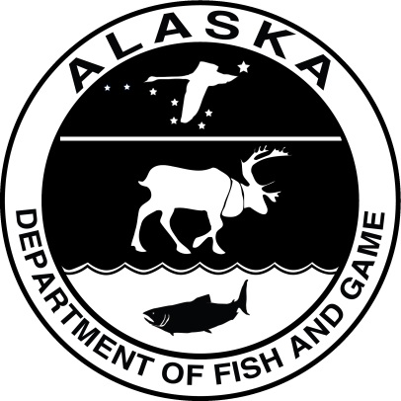

Month 2017

Alaska Department of Fish and Game Division of Commercial Fisheries

Symbols and Abbreviations

The following symbols and abbreviations, and others approved for the Système International d'Unités (SI), are used without definition in the following reports by the Divisions of Sport Fish and of Commercial Fisheries: Fishery Manuscripts, Fishery Data Series Reports, Fishery Management Reports, and Special Publications. All others, including deviations from definitions listed below, are noted in the text at first mention, as well as in the titles or footnotes of tables, and in figure or figure captions.

**Weights and measures (metric)**

centimeter cm

deciliter dL

gram g

hectare ha

kilogram kg

kilometer km

liter L

meter m

milliliter mL

millimeter mm

**Weights and measures (English)**

cubic feet per second ft3/s

foot ft

gallon gal

inch in

mile mi

nautical mile nmi

ounce oz

pound lb

quart qt

yard yd

**Time and temperature**

day d

degrees Celsius °C

degrees Fahrenheit °F

degrees kelvin K

hour h

minute min

second s

**Physics and chemistry**

all atomic symbols

alternating current AC

ampere A

calorie cal

direct current DC

hertz Hz

horsepower hp

hydrogen ion activity pH

(negative log of)

parts per million ppm

parts per thousand ppt,

‰

volts V

watts W

**General**

Alaska Administrative

Code AAC

all commonly accepted

abbreviations e.g., Mr., Mrs., AM, PM, etc.

all commonly accepted

professional titles e.g., Dr., Ph.D.,

R.N., etc.

at @

compass directions:

east E

north N

south S

west W

copyright ©

corporate suffixes:

Company Co.

Corporation Corp.

Incorporated Inc.

Limited Ltd.

District of Columbia D.C.

et alii (and others) et al.

et cetera (and so forth) etc.

exempli gratia

(for example) e.g.

Federal Information

Code FIC

id est (that is) i.e.

latitude or longitude lat or long

monetary symbols

(U.S.) $, ¢

months (tables and

figures): first three

letters Jan,...,Dec

registered trademark ®

trademark ™

United States

(adjective) U.S.

United States of

America (noun) USA

U.S.C. United States Code

U.S. state use two-letter abbreviations (e.g., AK, WA)

**Mathematics, statistics**

*all standard mathematical*

*signs, symbols and*

*abbreviations*

alternate hypothesis HA

base of natural logarithm *e*

catch per unit effort CPUE

coefficient of variation CV

common test statistics (F, t, χ2, etc.)

confidence interval CI

correlation coefficient

(multiple) R

correlation coefficient

(simple) r

covariance cov

degree (angular ) °

degrees of freedom df

expected value *E*

greater than >

greater than or equal to ≥

harvest per unit effort HPUE

less than <

less than or equal to ≤

logarithm (natural) ln

logarithm (base 10) log

logarithm (specify base) log2, etc.

minute (angular) '

not significant NS

null hypothesis HO

percent %

probability P

probability of a type I error

(rejection of the null

hypothesis when true) α

probability of a type II error

(acceptance of the null

hypothesis when false) β

second (angular) "

standard deviation SD

standard error SE

variance

population Var

sample var

Fishery data Series no. YY-XX

Assessment of spot shrimp abundance in Prince William Sound, 1992–2016

by

Joshua Mumm, Dr. Kenneth J. Goldman, and Jan Rumble

Alaska Department of Fish and Game, Division of Commercial Fisheries, Homer

Alaska Department of Fish and Game  
Division of Commercial Fisheries  
333 Raspberry Road, Anchorage, Alaska, 99518-1565

Month Year

ADF&G Fishery Data Series was established in 1987 for the publication of Division of Sport Fish technically oriented results for a single project or group of closely related projects, and in 2004 became a joint divisional series with the Division of Commercial Fisheries. Fishery Data Series reports are intended for fishery and other technical professionals and are available through the Alaska State Library and on the Internet: <http://www.adfg.alaska.gov/sf/publications/>. This publication has undergone editorial and peer review.

Joshua Mumm,

Dr. Kenneth J. Goldman,

and Jan Rumble

Alaska Department of Fish and Game, Division of Commercial Fisheries,

3298 Douglas Place, Homer, Alaska 99603 USA

This document should be cited as follows:

Mumm, J. Goldman,K.J.,and J. Rumble 2017. Assessment of spot shrimp abundance in Prince William Sound, 1992–2016. Alaska Department of Fish and Game, Division of Commercial Fisheries, Fishery Data Series. YY-XX, Anchorage.

The Alaska Department of Fish and Game (ADF&G) administers all programs and activities free from discrimination based on race, color, national origin, age, sex, religion, marital status, pregnancy, parenthood, or disability. The department administers all programs and activities in compliance with Title VI of the Civil Rights Act of 1964, Section 504 of the Rehabilitation Act of 1973, Title II of the Americans with Disabilities Act (ADA) of 1990, the Age Discrimination Act of 1975, and Title IX of the Education Amendments of 1972.

**If you believe you have been discriminated against in any program, activity, or facility please write:**

ADF&G ADA Coordinator, P.O. Box 115526, Juneau, AK 99811-5526

U.S. Fish and Wildlife Service, 4401 N. Fairfax Drive, MS 2042, Arlington, VA 22203

Office of Equal Opportunity, U.S. Department of the Interior, 1849 C Street NW MS 5230, Washington DC 20240

**The department’s ADA Coordinator can be reached via phone at the following numbers:**

(VOICE) 907-465-6077, (Statewide Telecommunication Device for the Deaf) 1-800-478-3648,

(Juneau TDD) 907-465-3646, or (FAX) 907-465-6078

**For information on alternative formats and questions on this publication, please contact:**

ADF&G, Division of Sport Fish, Research and Technical Services, 333 Raspberry Rd, Anchorage AK 99518 (907) 267-2375

TABLE OF CONTENTS

Page

LIST OF TABLES ii

LIST OF FIGURES ii

LIST OF APPENDICES ii

abstract 1

Introduction 1

Fishery History 1

CURRENT Management 2

Methods 2

Spatial Layout 2

Gear and Field Logistics 3

Biological Sampling 3

Analysis 3

Total Catch 3

Large Catch 4

Within-site 4

Survey-wide 5

Results 6

Survey-wide 6

Catch Rate 6

Size and Sex Composition 6

Area 1 6

Catch Rate 6

Size Composition 7

Area 2 7

Catch Rate 7

Size Composition 7

Area 3 7

Catch Rate 7

Size Composition 7

Discussion 7

Survey-wide CPUE 7

Survey Trends Since Reopening Commercial Fishery 8

Length Frequency Distributions 8

Size-at-sex 8

Comparison Between Harvest Areas 9

Conclusion 9

Acknowledgements 10

References Cited 10

TABLES AND FIGURES 12

APPENDIX A: Stations 25

APPENDIX B: CPUE by StatisTIcal Area 28

APPENDIX C: Ovigerity by statistical Area 30

# LIST OF TABLES

Table Page

Table 1. Total allowable harvests (TAH), guideline harvest levels (GHL), and harvests in PWS commercial and noncommercial shrimp pot fisheries, 2010–2016. 13

Table 2.–Catch and CPUE of spot shrimp in the in the PWS pot survey, 1992–2016. 14

Table 3.–Sex composition and carapace length of spot shrimp in the PWS spot survey. 15

Table 4.–CPUE of spot shrimp in the PWS pot survey and commercial pot fishery by harvest area. 16

# LIST OF FIGURES

Figure Page

Figure 1.–Pot shrimp harvest and pot survey CPUE of spot shrimp in PWS. 17

Figure 2.–PWS spot shrimp pot survey sites and commercial harvest areas. 18

Figure 3.–Survey-wide CPUE of spot shrimp in the PWS pot survey. 19

Figure 4.–Survey-wide mean carapace length ±1 SE of spot shrimp in the PWS pot survey. 19

Figure 5.–Length frequencies of spot shrimp in the PWS spot pot survey. . 20

Figure 6.–Length at 50% female (L50) of spot shrimp in the PWS pot survey. 21

Figure 7.–Length at 50% female (L50) by harvest area of spot shrimp in the PWS pot survey. 21

Figure 8.–Proportion of females in the spot shrimp catch of the PWS pot survey.. 22

Figure 9.–Proportion of females in the spot shrimp catch of the PWS pot survey by harvest area. 22

Figure 10.–CPUE of spot shrimp by harvest area in the PWS pot survey. . 23

Figure 11.–Mean carapace length of spot shrimp ±1 SE by harvest area in the PWS pot survey. 23

Figure 12.–Length frequencies of spot shrimp by harvest area in the PWS pot survey. 24

# LIST OF APPENDICES

Appendix A1.– Location and depth of stations used in the PWS pot survey. 26

Appendix B 1.–CPUE (lb/pot) of spot shrimp in the PWS spot survey and commercial fishery by statistical area. 29

Appendix C 1.–Percent of female spot shrimp with eggs in the PWS spot survey by statistical area. 31

# abstract

The Alaska Department of Fish and Game has conducted a pot survey for spot shrimp (*Pandalus platyceros*) in Prince William Sound annually since 1989. Information from the survey is combined with fishery performance to estimate surplus production and set guideline harvest limits. On average, 350 pots were fished each year, catching between 2,252 and 24,152 spot shrimp. Catch per unit effort of spot shrimp increased from 0.7 lb/pot in 1992 to a high of 2.8 lb/pot in 2016, with a low of 0.3 lb/pot in 1998. Other survey metrics (proportion female, mean length, and length at sex transition) showed no long-term trend. Of the 3 commercial harvest areas, Area 3 yielded the lowest CPUE, especially in the years following the 1998 low.

Key words Spot shrimp, *Pandalus platyceros*, Prince William Sound, pot survey

# Introduction

The Alaska Department of Fish and Game has conducted a pot survey for spot shrimp (*Pandalus platyceros*) in Prince William Sound (PWS) annually since 1989. The project began as a 3 year study on the effects of the Exxon Valdez Oil Spill (EVOS) (Trowbridge 1992). In 1992, the project was refocused as an assessment tool and has continued through the present (Trowbridge 1994). The primary objective of the survey is to provide a relative index of spot shrimp annual abundance in PWS. A Schaefer surplus production model incorporates this index with commercial and noncommercial fishery harvest and catch per unit effort (CPUE) to estimate harvestable surplus each year (Goldman et al. 2015). Guideline harvest limits (GHLs) are established from this harvestable surplus as stipulated by the management plan (5 AAC 31.214). This report summarizes survey results from 1992 to 2016 and includes commercial fishery information from 2010 to 2016.

Spot shrimp are distributed across the northeast Pacific from Unalaska to Baja California (Lowry 2007). Adults prefer structurally complex bottoms and in PWS are most abundant at depths of 25–75 fathoms (Lowry 2007; Trowbridge 1992). Larvae hatch in the spring and spend their first summer in the water column before settling in shallow eelgrass beds in the fall (Butler 1980). After approximately 3 years, the juveniles migrate to deeper rocky areas and mature as males (Kimker and Donaldson 1987). Being protandric hermaphrodites, like all Pandalids, they transition to being females after approximately 3–5 years as males (Kruse and Murphy 1989). In Alaska, females may live for another 3–5 years and reproduce annually (Trowbridge 1992; Love and Bishop 2005). Tagging studies in PWS suggest a maximum age range of 7 to 10 years (Kimker et al. 1996; Donaldson 1991), substantially longer than the faster growing populations in the warmer waters of British Columbia, Washington and California (Butler 1964; Lowry 2007) where the maximum age is thought to be 6 years. While planktonic larvae are advected by currents, adult spot shrimp are sedentary. One study found that tagged adults moved less than 1 mile over 3 years in Unakwik Inlet (Kimker et al. 1996). The slow growth, limited dispersal, predictable distribution, and harvest concentrated on the larger saleable female component of the stock predispose spot shrimp to serial depletion, overharvest and slow recovery (Orensanz et al. 1998).

# Fishery History

Commercial and noncommercial pot fisheries target spot shrimp in PWS. Commercial harvest was first documented in 1960 and remained at relatively low levels (< 25,000 lb) until 1979 when the fishery rapidly expanded (Figure 1). By 1986, harvest had peaked at nearly 300,000 lb, concurrent with a dramatic increase in effort. Year round seasons with no harvest restrictions were shortened to summer only openings in 1982 and the first Guideline Harvest Range (GHR) set at 75,000–145,000 lb. The GHR was increased to 150,000–200,000 lb in 1985 and an experimental harvest area was established in Montague Strait with no harvest or season restrictions (Donaldson 1989). Harvest declines in 1988 raised conservation concerns. Harvest well exceeded the GHR every year until 1989 when EVOS and partial area closures curtailed harvest. In 1990, gear restrictions were instituted and in 1991 the GHR was reduced to 10,000–40,000 lb. A department study following EVOS concluded the decline in abundance could mostly be explained by overfishing (Trowbridge 1992), although environmental conditions likely also contributed (Anderson and Piatt 1999; Hare and Mantua 2000). The commercial fishery was closed from 1992 through 2009. The noncommercial fishery remained open during the commercial closure and expanded considerably with the opening of road access to the port of Whitter in 2000 (Figure 1). Noncommercial harvest has not been consistently documented for all years but is available from permits between 2002 and 2006, and since 2009.

# CURRENT Management

The commercial fishery reopened under a new management plan in 2010. The plan established a harvestable surplus threshold of 110,000 lb for opening the commercial fishery (5 AAC 31.214). If the estimated harvestable surplus exceeds this threshold, 40% of the harvestable surplus is allocated to the commercial fishery and 60% to the noncommercial fishery. To manage conservatively, the plan also established 3 commercial harvest areas which are opened on a rotational basis, such that each area is given a resting period of 2 years to allow newly recruited females an opportunity to reproduce before being harvested (5 AAC 31.210(a); Figure 2). Since reopening under the new management plan, harvest has been relatively stable at approximately 150,000 lb (commercial and noncommercial combined), roughly half of the peak commercial harvest in 1986. In recent years, noncommercial has exceeded commercial harvest (Table 1; Figure 1).

The commercial management plan also includes: 1) stringent reporting regulations that require all shrimp fishermen to contact ADF&G within 24 hours of leaving to harvest shrimp, and to contact the department before landing, to provide all harvest information; 2) no more than 50% of the guideline harvest level may be harvested from any one statistical area; 3) a vessel operator may not have more than the legal limit of pot gear on the vessel or in the water; and 4) a person may only register one vessel to participate in the fishery during a registration year. The department also has the authority to determine each season the number of shrimp pots that may be operated from a vessel based on total number of registered vessels, estimated CPUE, and magnitude of the GHL, with the maximum number of allowable pots set at 100; this can change inseason. Also, fishing periods and operational hours are set by the department before the season begins and can change throughout the season.

# Methods

## Spatial Layout

The spatial layout of the survey consists of sites, each composed of several stations (Figure 2). One longlined string of pots is fished at each station. The number of sites, the number of stations per site, and the number of pots per station have all evolved over time.

The first 3 years of the project were designed to study the effects of EVOS, with 3 sites in the unoiled area and 3 sites in the oiled area. Two strata were fished at each site; one shallow (20–70 fathoms) and one deep (70–120 fathoms). In order to achieve the sampling objective of 500 shrimp per stratum, the most productive depths were sometimes repeatedly fished. Data from 1989–1991 were not included in our analysis because of differences in methods and data management.

The survey design was modified in 1992, when the primary objective shifted to developing a relative index of abundance. Depth stratification was abandoned and replaced with a single target depth range of 20­80 fathoms. The initial study and reports from commercial fishermen indicated that spot shrimp were concentrated at these depths. Other changes initiated in 1992 included adding 2 sites (Chenega and Prince of Wales) to the original 6 (Unakwik, Golden, Culross, Herring Bay, Junction Island, and Green Island). These 8 sites were fished from 1992 until 2009, when Long Bay replaced Green Island as the strong currents at Green Island caused repeated gear loss. In 2012, Bald Head Chris was added to enhance the geographic coverage of the survey, and in 2013, Valdez was added to provide a fishery independent assessment of the area which is heavily fished in the noncommercial fishery.

In addition to changes in sites, the number of stations per site and pots per station have also varied. From 1992 through 2015, 4 fixed stations, each comprised of a longlined string of 11 pots, were fished at each site. In 2016, the number of stations at each site was increased to 8 and the number of pots per station was reduced from 11 to 5.

## Gear and Field Logistics

One longlined string of pots was set at each station. Except for 2016, each string consisted of 11 pots, spaced 10 fathoms apart. Each string was buoyed at both ends. Anchors were added to both ends starting in 2009. The kite style pots measured 16” x 16” x 36”, and were covered with black fabric except for the 2 tunnels on opposing ends. The tunnels were made of 1/2” web and had 2.5” openings. Each pot was baited with a 2.5 quart perforated plastic jar of chopped herring. Pots were set in the morning or early afternoon and retrieved the following morning with typical soak times of between 20 and 22 hours. Lost, torn, or pots with open doors were excluded from analysis. The surveys were completed aboard a department research vessel during October. These pots do not fit the commercial pot specifications (5AAC 31.223); they are designed to catch shrimp from a larger size range.

## Biological Sampling

Shrimp catch in every pot was sorted to species, counted and weighed in aggregate. From 1992 through 2004, all spot shrimp were measured and sexed based on endopod morphology (Trowbridge 1992). In 2005, all female spot shrimp and half of the males were measured. Beginning in 2006, spot shrimp were measured from a single randomly selected pot at each station. Also beginning in 2006, individual shrimp were weighed. Bycatch of other species was sorted and counted, and beginning in 2006 also weighed.

## Analysis

Spot shrimp catch and CPUE (lb per pot) was calculated for both large (>32 mm) and all sizes. A carapace length of 32 mm is the approximate minimum marketable size.

### Total Catch

The total catch of all sizes of spot shrimp (*call*) was the sum of catches in individual pots:

$${\text{c}}_{\text{all} }\text{=}\sum_{\text{i=}\text{1}}^{\text{N}}{{\text{c}}_{{\text{all}}_{\text{i}}}}$$

where ${\text{c}}_{{\text{all}}_{\text{i}}}$ is the catch in pot *i*, and *N* is the number of pots successfully fished.

The CPUE $\text{(}{\overline{\text{c}}}_{\text{all}}\text{)}$ of all sizes was calculated by dividing the total catch by the total number of pots successfully fished:

$${\overline{\text{c}}}_{\text{all} }\text{= }\frac{{\text{c}}_{\text{all}}}{\text{N}}$$

with variance calculated as

$$\text{var(}{\overline{\text{c}}}_{\text{all}}\text{)} \text{= }\frac{\sum_{\text{i=}\text{1}}^{\text{N}}{{\left({{{\overline{\text{c}}}_{\text{all}}}_{\text{i}} \text{- }\text{c}}_{\text{all}} \right)}^{\text{2}}}}{\text{N}\text{(}\text{N-}\text{1)}}$$

### Large Catch

The catch of large spot shrimp was calculated using a ratio estimator based on the proportion large stratified by site.

#### Within-site

Within each site, the catch of large shrimp (${\text{c}}_{{\text{lrg}}_{\text{h}}}$)was estimated from the catch of all sizes and proportion large:

$${\hat{\text{c}}}_{{\text{lrg}}_{\text{h}}}\text{=} {\text{r}}_{\text{h}}{\text{c}}_{{\text{all}}_{\text{h}}}$$

where ${\text{c}}_{{\text{all}}_{\text{h}}}$ is catch of all sizes at site *h,* and

${\text{r}}_{\text{h}}$ is the proportion large measured at site *h*.

The proportion large was calculated from the measured shrimp pooled by site:

$${\text{r}}_{\text{h}} \text{= }\frac{\sum_{\text{i}\text{=1}}^{{\text{n}}_{\text{h}}}{{{\text{S}}_{\text{lrg}}}_{\text{i}}}}{\sum_{\text{i}\text{=1}}^{{\text{n}}_{\text{h}}}{{{\text{S}}_{\text{all}}}_{\text{i}}}}$$

where ${{\text{S}}_{\text{lrg}}}_{\text{i}}$ is the weight or count of large shrimp measured in sample pot *i,* and

${{\text{S}}_{\text{all}}}_{\text{i}}$ is the weight or count of all shrimp measured in sample pot *i*.

The variance of the proportion large was estimated as:

$${\text{v}\hat{\text{a}}\text{r}\text{(}\text{r}}_{\text{h}}\text{)} \text{=}\left(\frac{{\text{N}}_{\text{h}}\text{-}{\text{n}}_{\text{h}}}{{\text{N}}_{\text{h}}}\right)\left(\frac{{\text{s}}_{\text{h}}^{\text{2}}}{{\hat{\text{μ}}}_{{\text{all}}_{\text{h}}}^{\text{2}}{\text{n}}_{\text{h}}}\right)$$

where

$${\hat{\text{μ}}}_{{\text{all}}_{\text{h}}} \text{=} \frac{\text{1}}{{\text{n}}_{\text{h}}}\sum_{\text{i=}\text{1}}^{{\text{n}}_{\text{h}}}{{{\text{S}}_{\text{all}}}_{\text{i}}}$$

${\text{s}}_{\text{h}}^{\text{2}}\text{ =} \left.\sum_{\text{i=}\text{1}}^{{\text{n}}_{\text{h}}}{\frac{{\left({\hat{\text{c}}}_{{\text{lrg}}_{\text{i} }}\text{–}{ \text{r}}_{\text{h}}{\text{c}}_{{\text{all}}_{\text{i}}}\right)}^{\text{2}}}{{\text{n}}_{\text{h} }\text{-} \text{1}}}\right.$

${\text{μ}}_{\text{a}{\text{ll}}_{\text{h}}}$ is the average count or weight of lengths per pot at site *h*, $\frac{\text{1}}{{\text{N}}_{\text{h}}}\sum_{\text{i=}\text{1}}^{{\text{N}}_{\text{h}}}{{{\text{S}}_{\text{all}}}_{\text{i}}}$;

${\text{n}}_{\text{h}}$ is the number of pots sampled for length at site *h*; and

${\text{N}}_{\text{h}}$ is the total number of pots at site *h*.

The variance of the large catch was estimated as:

$$\text{v}\hat{\text{a}}\text{r}\text{(}{{\hat{\text{c}}}_{\text{lrg}}}_{\text{h}}\text{) }\text{=} \text{v}\hat{\text{a}}\text{r}\left({{\text{c}}_{\text{all}}}_{\text{h}}{ \text{r}}_{\text{h}}\right) \text{≈} {\left({{\text{c}}_{\text{all}}}_{\text{h}}\right)}^{\text{2}}\text{v}\hat{\text{a}}\text{r}\left({\text{r}}_{\text{h}}\right) \text{+}{ \left({\text{r}}_{\text{h}}\right)}^{\text{2}}\text{var}\left({{\text{c}}_{\text{all}}}_{\text{h}}\right) \text{-} \text{v}\hat{\text{a}}\text{r}\left({\text{r}}_{\text{h}}\right)\text{var}\left({{\text{c}}_{\text{all}}}_{\text{h}}\right)$$

where $$\text{var}\left({{\text{c}}_{\text{all}}}_{\text{h}}\right) \text{=} \sum_{\text{i=}\text{1}}^{{\text{N}}_{\text{h}}}{\frac{{\left({\text{c}}_{{\text{all}}_{\text{i} }}\text{-} {\overline{\text{c}}}_{{\text{all}}_{\text{i}}}\right)}^{\text{2}}}{{\text{N}}_{\text{h}}\text{-}\text{1}}}$$

#### Survey-wide

The survey-wide catch of large shrimp ( ${\text{c}}_{\text{lrg}}\text{)}$ was estimated by summing the estimated large catch within each site:

$${\hat{\text{c}}}_{\text{lrg}} \text{=}\sum_{\text{h=}\text{1}}^{\text{L}}{{{\hat{\text{c}}}_{\text{lrg}}}_{\text{h}}}$$

where *L* is the number of sites.

Large CPUE (${\overline{\text{c}}}_{\text{lrg}})$ was estimated as

$${\overline{\text{c}}}_{\text{lrg}} \text{=} \frac{{\text{c}}_{\text{lrg}}}{\text{N}}$$

with variance estimated from the sum of the estimated variances of large catch within each site:

$$\hat{\text{var}}\text{(}{\overline{\text{c}}}_{\text{lrg}}\text{) }\text{=} \frac{\sum_{\text{h=}\text{1}}^{\text{L}}{\hat{\text{var}}(}{\text{c}}_{{\text{lrg}}_{\text{h}}}\text{)}}{{\text{N}}^{\text{2}}}$$

Since individual shrimp were not weighed prior to 2006, those weights were estimated using the length-weight relationship fit to shrimp sampled in 2006–2010:

$$\text{w =}{\text{ e}}^{\text{-7.004908}}{\text{l}}^{\text{2.863889}}$$

where *w* = whole weight in grams, and *l* = carapace length in mm.

Size at sex transition (L50) was estimated using logistic regression.

The boundary between commercial harvest commercial fishing Areas 2 and 3 was shifted north in 2015 (5 AAC 31.210(a)), effectively reallocating the Herring Bay site from Area 2 to 3 (Figure 2). For consistency and to facilitate interpretation of temporal trends, the Herring Bay site was considered part of Area 2 throughout the time series presented here. The Valdez site was not included in survey or area-wide statistics because it is outside the commercial harvest areas.

# Results

## Survey-wide

An average of 350 pots were successfully fished each year during the survey, with a range from 264 to 395 pots (Table 1). The total catch of spot shrimp averaged 474 lb and 10,802 shrimp, and ranged from 76 lb and 2,252 shrimp in 1998, to 838 lb and 24,152 shrimp in 2007.

### Catch Rate

The survey-wide CPUE of all sizes of spot shrimp averaged 1.32 lb/pot annually, and ranged from 0.29 to 2.75 between 1992 and 2016 (Table 1). The CPUE of large shrimp averaged 0.86 and ranged from 0.14 to 1.98 lb/pot. Both large and all CPUE generally decreased from 1992 to low levels in 1998 with a slight rise in 1995 (Figure 3). Over the next decade, the CPUE of both size classes increased with CPUE of all sizes peaking in 2008. Both catch rates declined in 2010, then increased again in 2011. From 2012 to 2015 the catch rates of both declined, before surging to record highs in 2016.

### Size and Sex Composition

The survey-wide annual mean carapace length was 30.6 mm, and ranged from 28.3 to 34.1 (Figure 4). Although no general long-term trend is apparent, mean size has varied slightly from year to year with some similarity to variation in CPUE. Similar to CPUE, mean length declined from 1992 to 1994, increased in 1995, then decreased again through 1998. Mean size increased from 1998 to 2001, then decreased through 2007. Mean size reached a high in 2011, then generally declined over the remainder of the time series. In 2016, the mean size was near the long-term average.

Dominant size classes are apparent in the length frequency distributions (Figure 5). Growth in some of these modes can be tracked over time. For example, the recruitment pulse at 25 mm in 2005 progressively shifts larger to 37 mm in 2011. This particular recruitment pulse coincides, and may have contributed to the increase in CPUE from 2005 to 2011, appearing first as an increase in CPUE of all sizes of shrimp, then later as an increase in CPUE of large shrimp. In 2016, size modes were at 27, 33, and 44 mm. The smallest measured female was 34 mm.

The length at 50% female (L50) averaged 40.2 mm over the 1992–2016 time series with no apparent long-term trend and little variation between harvest areas (Figures 6 and 7). Females comprised 10% of the spot shrimp catch on average (Table 3; Figure 8). Following a maximum of 25% in 2011, the female component of the catch dropped to 8% in 2015 before returning above the long-term average in 2016. A greater proportion of the catch was female in Area 1 than the other 2 areas (Figure 9).

## Area 1

### Catch Rate

In Area 1, the long-term average CPUE of all sizes and large spot shrimp was 1.7 and 1.4 lb/pot (Table 4; Figure 10). A roughly four-fold increase in CPUE occurred in 2004, with CPUE of large shrimp averaging 0.5 lb/pot prior to 2004, and 2.2 lb/pot after. Some of the interannual variation apparent in the survey-wide values is also apparent in the Area 1 CPUE. For example, the local minima observed in 1994 and 1998, and maxima in 2008, 2012 and 2016 paralleled those in the survey-wide values.

### Size Composition

Carapace length in Area 1 was the greatest of the 3 areas with a long-term average of 33.9 mm and a range of 29.2–37.4 mm (Figure 11). Mean carapace length decreased slightly following a high in 2010–2012; however the 2016 value was near the long term average. In the size frequency distributions, a dominant mode grew from 31 mm in 2004 to 40 mm in 2008 (Figure 12). Prior to and after this time period the distribution was multimodal. In 2016, size modes were present at 24, 33, and 44 mm.

## Area 2

### Catch Rate

In Area 2, the long-term average CPUE of all sizes was 1.7 lb/pot, nearly identical to that in Area 1 (Figure 10). The CPUE of large shrimp was intermediate to the other two areas at 0.9 lb/pot. Catch rates have generally increased in Area 2 over the history of the survey although less abruptly than in Area 1. Minima occurred in 1994 and 1998, and maxima in 2007 and 2016.

### Size Composition

Mean carapace length in Area 2 was 29.7 mm with a range of 27.5 to 32.9, substantially less than Area 1 and similar to Area 3 (Figure 11). After highs in 2010 and 2011, mean carapace length declined to near the long-term average in 2016. A dominant size class can be tracked from 20 mm in 2003, to 46 mm in 2013 (Figure 12). In 2016, size modes were apparent at 27, 33 and 45 mm.

## Area 3

### Catch Rate

Long-term average CPUE in Area 3 was 0.8 lb/pot for all shrimp and 0.5 lb/pot of large spot shrimp, substantially less than the other two areas (Figure 10). During the early years of the survey, catch rates in Area 3 were similar to the other two areas; however Area 3 did not recover as rapidly or as substantially from the 1998 low as the other two areas. Following the 2008 peak, Area 3 catch rates generally trended slightly downward.

### Size Composition

Mean carapace length in Area 3 was 30.6 mm and ranged from 27.6 to 34.5, similar to Area 2 and smaller than Area 1 (Figure 11). The maximum mean carapace length was observed in 2010, and was close to the long-term average in the 2016 survey. A strong size class grew from 25 mm in 2006, to 32 mm in 2009 (Figure 12). In 2016, modes were observed at 27, 34, and 47 mm.

# Discussion

## Survey-wide CPUE

Survey-wide CPUE of both large and all sizes of shrimp have generally increased from 1992 to 2016 (Figure 3). If the CPUE of all sizes from the first three years of the survey (1989–1991) are considered (1.3, 0.9, and 1.3 lb/pot) (Trowbridge 1994), a general decline in CPUE is evident from 1989 to 1998, followed by an overall increase from 1998 to 2016 (Figure 1). Results from the first three years of the survey should be cautiously compared to results from later years due to differences in methods, especially site locations and depths fished.

Ideally, CPUE from the virgin unexploited stock would be available as a baseline for comparing with current survey results. Unfortunately, this survey began immediately following the collapse of the commercial fishery in the 1980’s, thus it is difficult to ascertain where the current abundance stands relative to the unexploited abundance or even to the abundance during the height of the historic commercial fishery (Figure 1). Nevertheless, 1.3 lb/pot of all sizes of shrimp was tentatively suggested as a target threshold necessary for a commercial fishery (Trowbridge 1994). This figure is comparable to the commercial fishery CPUE after full development in the 1980’s, was observed in the survey in 1989 and 1991, and is also near the 1992 to 2016 long-term survey average. The survey CPUE has been above this threshold every year since 2004.

## Survey Trends Since Reopening Commercial Fishery

Following the increase in noncommercial harvest in the 2000’s, and the reopening of the commercial fishery in 2010, the CPUE of large shrimp, mean carapace length and proportion of females all declined from 2011 to 2015 (Figures 3, 4 and 8). Since mean size and proportion female are determined by the ratio of small shrimp relative to large shrimp, viewed in isolation, the declines in those two metrics could indicate either an increase in the abundance of small shrimp or a decrease in the abundance of large shrimp. However, the commensurate decline in CPUE of large shrimp indicates the later was operative – the decline in mean size and proportion female were due to a declining abundance of large shrimp rather than an increasing abundance of small shrimp. These declines may have raised conservation concerns if they had not followed historic highs in 2011; even after 4 consecutive years of decline, the 2015 values of each were near the long-term average. Potential concerns were further allayed by the 2016 survey when the declining trend in all 3 metrics reversed. In particular, the 2016 survey-wide CPUE of both large and all sizes surged to new records. Preliminary results from 2017 indicate a continuing upward trend.

## Length Frequency Distributions

The progression in modes seen in the length frequency distributions, suggest a mean growth rate of approximately 2–3 mm/yr for the size range 25–45 mm. This growth rate is roughly consistent with the 3 mm/yr reported for tagged shrimp in Prince William Sound (Kimker et al. 1996). Based on the dominant mode at 27 mm and record CPUE in 2016, in conjunction with the presumed growth rate, the survey CPUE of large shrimp is expected to increase in 2017 and 2018.

## Size-at-sex

Declines in size of sex transition in a related pandalid, the northern pink shrimp (*P. borealis)*, have been controversially suggested as a compensatory response to stock declines, in accordance with sex allocation theory (Charnov 1982; Charnov and Anderson 1989). However, increases in L50 have also been observed during periods of low abundance (Koeller et al. 2000). Instead, changes in L50 are perhaps most directly used as an indication of growth rate and maximum size (Koeller et al. 2003). Size at transition in pandalidsis inversely related to growth rate, and directly related to maximum size by a relatively invariant proportionality constant (~0.8) (Charnov and Skuladottir 2000; Skuladottir et al. 2007; Lowry 2007). In light of this, the lack of long-term trend in L50 observed in the PWS survey suggests that growth rate and maximum size has remained relatively unchanged from 1992 to 2016. Similarly, growth rates appear to differ little between areas based on little difference in L50. Although not explicitly examined, our data do not appear to support the utility of L50 as an indicator of stock density, since L50 remained relatively stable while over the same time period CPUE roughly tripled. The length at sexual transition observed in the PWS survey fall within the range reported for Southeast Alaska (Bishop et al. 2009).

## Comparison Between Harvest Areas

Survey CPUE of large shrimp decreased across the 3 commercial harvest areas from north to south. Most of the differences can be attributed to varying recoveries from the 1998 low. While the CPUE of all 3 areas were roughly similar prior to 1998, the following years saw a dramatic increase in CPUE in Area 1, a moderate increase in Area 2, and only a minor increase in Area 3 (Figure 10). Area 3 exhibited a mostly flat trend in CPUE from 1992 to 2016 as compared to the general upward trend in the other 2 areas. The southwestern portion of sound was the first location to have fishery closures implemented due to the declining stock in the 1980s (Donaldson 1991). Preliminary results from the 2017 survey show an increase in total CPUE of all sizes in each area.

The differences in commercial fishery performance between the 3 areas mirrored those seen in the survey, with CPUE averaged over years decreasing from north to south at 2.0, 1.7, and 1.1 lb/pot for Areas 1, 2 and 3, respectively (Table 3). No clear interannual trends in CPUE are evident in the commercial data, although the time series is limited. Since reopening in 2010, the fishery has been prosecuted 3 years in Areas 1 and 2, and only 2 years in Area 3.

## Conclusion

The PWS spot shrimp pot survey constitutes a 29 year time series, spanning from immediately after the collapse of the commercial fishery and EVOS in 1989 to present. Following the commercial closure in 1992, the survey CPUE declined further to a low in 1998. This decline coincided with a general decline in shellfish abundance throughout the greater Gulf of Alaska (Bechtol 1997, Orensanz et al. 1998, Anderson and Piatt 1999). Following the 1998 low, survey CPUE steadily increased for the next 10 years. After peaking in 2008, CPUE oscillated and declined somewhat through 2015; however in 2016 survey CPUE surged to record highs and preliminary results from the 2017 survey indicate an additional increase. Furthermore, size compositions from the 2016 survey suggest this increase may continue through 2018. Other survey metrics have fluctuated over the course of the survey, with no apparent long-term trends. Although the time series of commercial fishery data following the 2010 reopening is limited, owing especially to the rotational openings, no trends are apparent in the commercial CPUE evaluated by area. The department will continue to monitor survey and fishery performance. Currently, none of the metrics examined to evaluate the abundance and composition of the spot shrimp stock in PWS warrant a change to the management strategy.

# Acknowledgements

Given the duration of this survey, listing all participants is not feasible. Some of the more notable contributors include Charlie Trowbridge and Wayne Donaldson who were instrumental in designing the original survey and early reporting. Karen Swartzbart has been responsible for most of the gear preparation, meticulously recorded data, and provided crucial consistency to coordinating field work over the decades. Margret Spahn documented evolving field methods and migrated survey data into the current database. Chris Russ provided commercial harvest and regulatory spatial data. Dave Anderson, Dave Branshaw, and Mark Hottmann skippered the R/V Solstice, Montague and Pandalus. Cordova shellfish biologists Maria Wessel, and Bob Bercelli performed much of the field work, data entry, and reporting. Xinxian Zhang provided biometric support.

# References Cited

Anderson, P., and J. Piatt 1999. Community reorganization in the Gulf of Alaska following ocean climate regime shift. Marine Ecology Progress Series. 189:117–­123.

Bechtol, W. R. 1997. Changes in forage fish populations in Kachemak Bay, Alaska, 1976-1995. Pages 441–­455 [*In*]: Forage Fishes in Marine Ecosystems. Alaska Sea Grant College Program Report 97-01. University of Alaska, Fairbanks.

Bishop, G., C. Siddon, and J. Bednarski. 2009. Stock status of spot shrimp in Southeast Alaska prior to the 2008–09 season. Alaska Department of Fish and Game, Fisheries Data Series 09-46, Anchorage.

Butler, T. H. 1964. Growth, reproduction and distribution of pandalid shrimps in British Columbia. Journal of Fisheries Research Board of Canada. 21:1403–1452.

Butler, T. H. 1980. Shrimps of the Pacific coast of Canada. Canadian Bulletin of Fisheries and Aquatic Sciences. Bulletin 202.

Charnov, E. L. 1982. The theory of sex allocation. Princeton University Press, Princeton, NJ.

Charnov, E.L., Anderson, P.J., 1989. Sex change and population fluctuations in pandalid shrimp. American Naturalist. 134:824–827.

Charnov, E.L., Skúladóttir, U., 2000. Dimensionless invariants for the optimal size (age) of sex change. Evolutionary Ecology Research. 2:1067–1071.

Donaldson, W. 1989. Synopsis of th**e** Montague Strait experimental harvest area 1985-1998. Alaska Department of Fish and Game, Division of Commercial Fisheries, Regional Information Report 2C89-04, Cordova.

Donaldson, W. 1991. Prince William Sound management area 1990 shellfish annual management report. Alaska Department of Fish and Game, Division of Commercial Fisheries, Regional Information Report 2C91-04, Anchorage.

Goldman, K. J., M. Wessel, X. Zhang, and J. Rumble. 2015. Assessment of spot shrimp, Pandalus platyceros, abundance in Prince William Sound, 2015 through 2017. Alaska Department of Fish and Game, Regional Operational Plan ROP.CF.2A.2015.01, Homer.

Hare, S.R. and Mantua, N.J., 2000. Empirical evidence for North Pacific regime shifts in 1977 and 1989. Progress in oceanography, 47:103–145.

Koeller P, Mohn R, and M. Etter. 2000. Density dependant sex change in northern shrimp, Pandalus borealis, on the Scotian Shelf. Journal of Northwest Atlantic fishery science. 27:107–18.

Koeller P.A., Covey M, King M. 2003. Is size at sex transition an indicator of growth or abundance in pandalid shrimp?. Fisheries Research. 65:217–230.

Kimker, A. and W. Donaldson 1987. Summary of the 1986 streamer tag application and overview of the tagging project for spot shrimp in Prince William Sound. Alaska Department of Fish and Game, Division of Commercial Fisheries, Prince William Sound Data Report 87-07, Cordova.

Kimker, A., W. Donaldson and W. R. Bechtol. 1996. Spot shrimp growth in Unakwik Inlet, Prince William Sound, Alaska. Alaska Fishery Research Bulletin. 3:1–8.

Kruse, G. and P. Murphy. 1989. Summary of statewide shrimp workshop held in Anchorage during October 24-26, 1988. Alaska Department of Fish and Game, Division of Commercial Fisheries, Regional Information Report No. 5J89-05, Juneau.

Lowry, N. 2007. Biology and fisheries for the spot prawn (Pandalus platyceros, Brandt 1851). Ph.D. dissertation. University of Washington, School of Aquatic and Fisheries Sciences.

Love, D. C. and G. Bishop. 2005. Pot Shrimp Stock Assessment Survey Results from 1996-2003 in Districts 3, 7, 12, and 13 of Southeast Alaska. Alaska Department of Fish and Game, Division of Commercial Fisheries, Regional Information Report 1J04-08, Juneau.

Orensanz, J. M., J. L. Armstrong, D. A. Armstrong, and R. Hilborn. 1998. Crustacean resources are vulnerable to serial depletion - The multifaceted decline of crab and shrimp fisheries in the greater Gulf of Alaska. Reviews in Fish Biology and Fisheries 8:117–176.

Skúladóttir, U., G. Pétursson, and S. H. Brynjólfsson. 2007. The Biology of Northern Shrimp (Pandalus borealis) on the Flemish Cap. Journal of Northwest Atlantic Fishery Science. 37: 147–164.

Trowbridge, Charles. 1992. Injury to Prince William Sound spot shrimp, Exxon Valdez Oil Spill State/Federal Natural Resource Damage Assessment Final Report (Subtidal Study Number 5), Alaska Department of Fish and Game, Commercial Fisheries Management and Development Division, Anchorage.

Trowbridge, C. 1994. Spot shrimp, *Pandalus platyceros*, surveys in the Prince William Sound Management Area, 1989–1993. Alaska Department of Fish and Game, Division of Commercial Fisheries Management and Development, Regional Information Report No. 2A94-31, Anchorage.

# TABLES AND FIGURES

Table .–Total allowable harvests (TAH), guideline harvest levels (GHL), and harvests in PWS commercial and noncommercial shrimp pot fisheries, 2010–2016.

|  |  |  |  |  |  |  |  |  |
| --- | --- | --- | --- | --- | --- | --- | --- | --- |
|  |  | GHL (lb) | |  | Shrimp harvest (lb) | | | % of TAH |
| Year | TAH (lb) | Noncommercial | Commercial |  | Noncommercial | Commercial | Total |
| 2010 | 137,500 | 82,500 | 55,000 |  | 142,146 | 45,349 | 187,495 | 139% |
| 2011 | 131,900 | 79,140 | 52,760 |  | 95,924 | 52,694 | 148,618 | 113% |
| 2012 | 128,100 | 76,860 | 51,240 |  | 90,385 | 21,561 | 111,946 | 87% |
| 2013 | 165,750 | 99,450 | 66,300 |  | 85,988 | 61,644 | 147,631 | 89% |
| 2014 | 166,500 | 99,900 | 66,600 |  | 89,155 | 68,464 | 157,619 | 95% |
| 2015 | 167,000 | 100,000 | 67,000 |  | 92,071 | 23,138 | 115,209 | 69% |
| 2016 | 117,653 | 70,500 | 47,061 |  | 102,785 | 48,346 | 151,131 | 128% |

Table .–Catch and CPUE of spot shrimp in the in the PWS pot survey, 1992–2016.

|  |  |  |  |  |  |  |  |  |  |  |  |  |
| --- | --- | --- | --- | --- | --- | --- | --- | --- | --- | --- | --- | --- |
|  |  | All sizes | | | | |  | Large (> 32mm) | | | | |
|  |  | Catch | |  | Catch per pot | |  | Catch | |  | Catch per pot | |
| Year | Pots | lb | Count |  | lb | Count |  | lb | Count |  | lb | Count |
| 1992 | 349 | 249 | 5,009 |  | 0.71 | 14.35 |  | 191 | 3,032 |  | 0.55 | 8.69 |
| 1993 | 325 | 121 | 2,434 |  | 0.37 | 7.49 |  | 87 | 1,008 |  | 0.27 | 3.10 |
| 1994 | 355 | 145 | 4,128 |  | 0.41 | 11.63 |  | 66 | 990 |  | 0.19 | 2.79 |
| 1995 | 350 | 206 | 5,053 |  | 0.59 | 14.44 |  | 118 | 1,869 |  | 0.34 | 5.34 |
| 1996 | 350 | 182 | 4,618 |  | 0.52 | 13.19 |  | –a | –a |  | –a | –a |
| 1997 | 345 | 142 | 3,835 |  | 0.41 | 11.12 |  | 73 | 1,117 |  | 0.21 | 3.24 |
| 1998 | 264 | 76 | 2,252 |  | 0.29 | 8.53 |  | 38 | 571 |  | 0.14 | 2.16 |
| 1999 | 346 | 165 | 4,392 |  | 0.48 | 12.69 |  | 76 | 1,088 |  | 0.22 | 3.14 |
| 2000 | 349 | 245 | 6,545 |  | 0.70 | 18.75 |  | 137 | 2,182 |  | 0.39 | 6.25 |
| 2001 | 351 | 331 | 7,034 |  | 0.94 | 20.04 |  | 225 | 3,456 |  | 0.64 | 9.85 |
| 2002 | 304 | 377 | 8,797 |  | 1.24 | 28.94 |  | 247 | 3,270 |  | 0.81 | 10.76 |
| 2003 | 352 | 398 | 9,333 |  | 1.13 | 26.51 |  | 277 | 4,132 |  | 0.79 | 11.74 |
| 2004 | 352 | 502 | 12,593 |  | 1.43 | 35.78 |  | 294 | 4,161 |  | 0.83 | 11.82 |
| 2005 | 349 | 481 | 14,453 |  | 1.38 | 41.41 |  | 218 | 3,525 |  | 0.63 | 10.10 |
| 2006 | 346 | 552 | 14,203 |  | 1.60 | 41.05 |  | 288 | 4,479 |  | 0.83 | 12.94 |
| 2007 | 349 | 838 | 24,152 |  | 2.40 | 69.20 |  | 369 | 6,034 |  | 1.06 | 17.29 |
| 2008 | 348 | 893 | 23,004 |  | 2.56 | 66.10 |  | 382 | 6,086 |  | 1.10 | 17.49 |
| 2009 | 351 | 825 | 17,622 |  | 2.35 | 50.21 |  | 518 | 7,874 |  | 1.48 | 22.43 |
| 2010 | 350 | 478 | 8,585 |  | 1.37 | 24.53 |  | 389 | 5,944 |  | 1.11 | 16.98 |
| 2011 | 350 | 687 | 11,627 |  | 1.96 | 33.22 |  | 590 | 8,004 |  | 1.69 | 22.87 |
| 2012 | 392 | 834 | 15,928 |  | 2.13 | 40.63 |  | 626 | 8,280 |  | 1.60 | 21.12 |
| 2013 | 392 | 744 | 14,453 |  | 1.90 | 36.87 |  | 536 | 7,176 |  | 1.37 | 18.31 |
| 2014 | 393 | 752 | 16,051 |  | 1.91 | 40.84 |  | 549 | 8,207 |  | 1.40 | 20.88 |
| 2015 | 395 | 629 | 14,118 |  | 1.59 | 35.74 |  | 400 | 5,249 |  | 1.01 | 13.29 |
| 2016 | 359 | 986 | 19,821 |  | 2.75 | 55.21 |  | 711 | 9,199 |  | 1.98 | 25.62 |

a  Biological data from 1996 are missing.

Table .–Sex composition and carapace length of spot shrimp in the PWS spot survey, 1992–2016.

|  |  |  |  |  |  |  |  |  |  |  |  |
| --- | --- | --- | --- | --- | --- | --- | --- | --- | --- | --- | --- |
|  | Percent male | Percent female | Percent of females w/ eggs |  | Male carapace length (mm) | | |  | Female carapace length (mm) | | |
| Year |  | mean | n | SE |  | mean | n | SE |
| 1992 | 88.2 | 11.8 | 96.8 |  | 32.0 | 4,221 | 0.07 |  | 42.1 | 563 | 0.10 |
| 1993 | 80.6 | 19.4 | 97.7 |  | 28.0 | 1,960 | 0.14 |  | 42.6 | 472 | 0.10 |
| 1994 | 95.1 | 4.9 | 95.5 |  | 27.5 | 3,868 | 0.07 |  | 43.4 | 201 | 0.16 |
| 1995 | 95.7 | 4.3 | –a |  | 29.2 | 4,831 | 0.07 |  | 43.5 | 217 | 0.18 |
| 1996 | 94.9 | 5.1 | –b |  | –b | –b | –b |  | –b | –b | –b |
| 1997 | 94.1 | 5.9 | –a |  | 28.0 | 3,584 | 0.08 |  | 42.2 | 224 | 0.15 |
| 1998 | 94.6 | 5.4 | 99.2 |  | 27.7 | 2,130 | 0.11 |  | 43.9 | 121 | 0.23 |
| 1999 | 94.3 | 5.7 | 97.8 |  | 28.0 | 3,703 | 0.07 |  | 43.1 | 224 | 0.16 |
| 2000 | 95.1 | 4.9 | 97.2 |  | 28.6 | 6,224 | 0.06 |  | 43.8 | 318 | 0.16 |
| 2001 | 92.7 | 7.3 | 99.6 |  | 30.8 | 6,520 | 0.06 |  | 43.8 | 513 | 0.11 |
| 2002 | 91.0 | 9.0 | 98.5 |  | 28.5 | 7,825 | 0.06 |  | 44.1 | 776 | 0.09 |
| 2003 | 92.0 | 8.0 | 99.7 |  | 29.5 | 8,555 | 0.06 |  | 45.4 | 748 | 0.09 |
| 2004 | 91.5 | 8.5 | 97.3 |  | 28.7 | 11,525 | 0.05 |  | 44.4 | 1,068 | 0.10 |
| 2005 | 95.0 | 5.0 | 95.0 |  | 28.1 | 7,071 | 0.05 |  | 43.7 | 737 | 0.13 |
| 2006 | 91.6 | 8.4 | 91.7 |  | 28.1 | 1,085 | 0.17 |  | 41.1 | 99 | 0.34 |
| 2007 | 94.2 | 5.8 | 83.7 |  | 28.2 | 2,098 | 0.09 |  | 41.4 | 129 | 0.28 |
| 2008 | 93.4 | 6.6 | 81.4 |  | 29.2 | 2,215 | 0.08 |  | 41.4 | 157 | 0.26 |
| 2009 | 86.2 | 13.8 | 88.0 |  | 30.4 | 1,513 | 0.10 |  | 41.6 | 242 | 0.19 |
| 2010 | 81.8 | 18.2 | 93.5 |  | 32.4 | 826 | 0.16 |  | 41.5 | 184 | 0.23 |
| 2011 | 74.8 | 25.2 | 99.1 |  | 31.5 | 957 | 0.20 |  | 41.8 | 322 | 0.17 |
| 2012 | 84.7 | 15.3 | 90.8 |  | 29.9 | 1,386 | 0.15 |  | 42.6 | 250 | 0.16 |
| 2013 | 85.7 | 14.3 | 87.1 |  | 29.9 | 1,161 | 0.15 |  | 43.9 | 194 | 0.20 |
| 2014 | 89.2 | 10.8 | 93.1 |  | 30.2 | 1,300 | 0.13 |  | 44.6 | 158 | 0.31 |
| 2015 | 91.7 | 8.3 | 98.3 |  | 29.1 | 1,300 | 0.16 |  | 44.8 | 118 | 0.30 |
| 2016 | 86.8 | 13.2 | 99.6 |  | 29.2 | 3,337 | 0.09 |  | 44.7 | 509 | 0.13 |

a Ovigerity data from 1995 and 1997 are missing.

b Biological data from 1996 are missing.

Table .–CPUE of spot shrimp in the PWS pot survey and commercial pot fishery by harvest area, 1992–2016.

|  |  |  |  |  |  |  |  |
| --- | --- | --- | --- | --- | --- | --- | --- |
|  | Survey CPUE (lb/pot) | | |  | Commercial CPUE (lb/pot) | | |
| Year | Area 1 | Area 2 | Area 3 |  | Area 1 | Area 2 | Area 3 |
| 1992 | 0.86 | 0.62 | 0.75 |  | nd | nd | nd |
| 1993 | 0.69 | 0.48 | 0.19 |  | nd | nd | nd |
| 1994 | 0.40 | 0.41 | 0.41 |  | nd | nd | nd |
| 1995 | 0.67 | 0.61 | 0.55 |  | nd | nd | nd |
| 1996 | 0.58 | 0.53 | 0.50 |  | nd | nd | nd |
| 1997 | 0.50 | 0.40 | 0.40 |  | nd | nd | nd |
| 1998 | 0.22 | 0.38 | 0.19 |  | nd | nd | nd |
| 1999 | 0.22 | 0.73 | 0.35 |  | nd | nd | nd |
| 2000 | 0.40 | 0.77 | 0.73 |  | nd | nd | nd |
| 2001 | 1.14 | 1.19 | 0.71 |  | nd | nd | nd |
| 2002 | 0.77 | 1.99 | 0.65 |  | nd | nd | nd |
| 2003 | 0.61 | 1.75 | 0.80 |  | nd | nd | nd |
| 2004 | 3.12 | 1.82 | 0.71 |  | nd | nd | nd |
| 2005 | 1.66 | 1.92 | 0.89 |  | nd | nd | nd |
| 2006 | 2.93 | 1.84 | 1.08 |  | nd | nd | nd |
| 2007 | 3.58 | 3.23 | 1.49 |  | nd | nd | nd |
| 2008 | 3.46 | 3.17 | 1.87 |  | nd | nd | nd |
| 2009 | 2.79 | 2.67 | 1.75 |  | nd | nd | nd |
| 2010 | 1.87 | 1.63 | 0.77 |  | 2.52 | nd | nd |
| 2011 | 3.67 | 2.19 | 0.61 |  | nd | 1.78 | nd |
| 2012 | 2.94 | 2.32 | 1.12 |  | nd | nd | 1.10 |
| 2013 | 1.79 | 2.55 | 1.35 |  | 1.77 | nd | nd |
| 2014 | 1.98 | 2.73 | 1.03 |  | nd | 1.65 | nd |
| 2015 | 1.84 | 2.48 | 0.46 |  | nd | nd | 1.16 |
| 2016 | 3.38 | 3.61 | 1.26 |  | 1.77 | nd | nd |

*Note:* All sizes of shrimp are included.

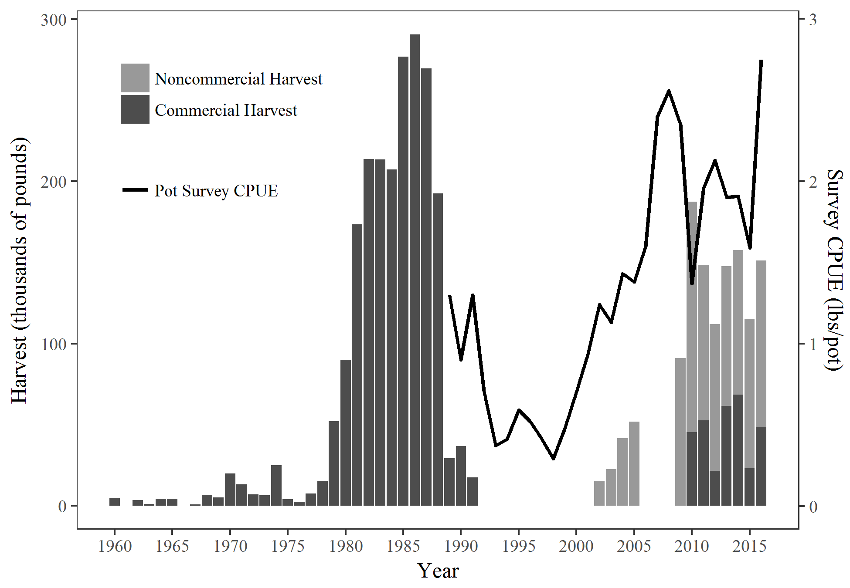

Figure .–Pot shrimp harvest and pot survey CPUE of spot shrimp in PWS.

*Note:* Survey CPUE includes all sizes.

*Note:* The commercial fishery was closed from 1992–2009.

*Note:* Noncommercial harvest is unavailable for the years prior to 2002 and for 2006–2008, because harvest permits were not required.

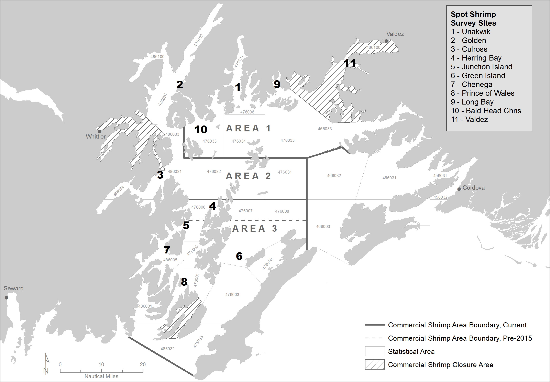

Figure .–PWS spot shrimp pot survey sites and commercial harvest areas.

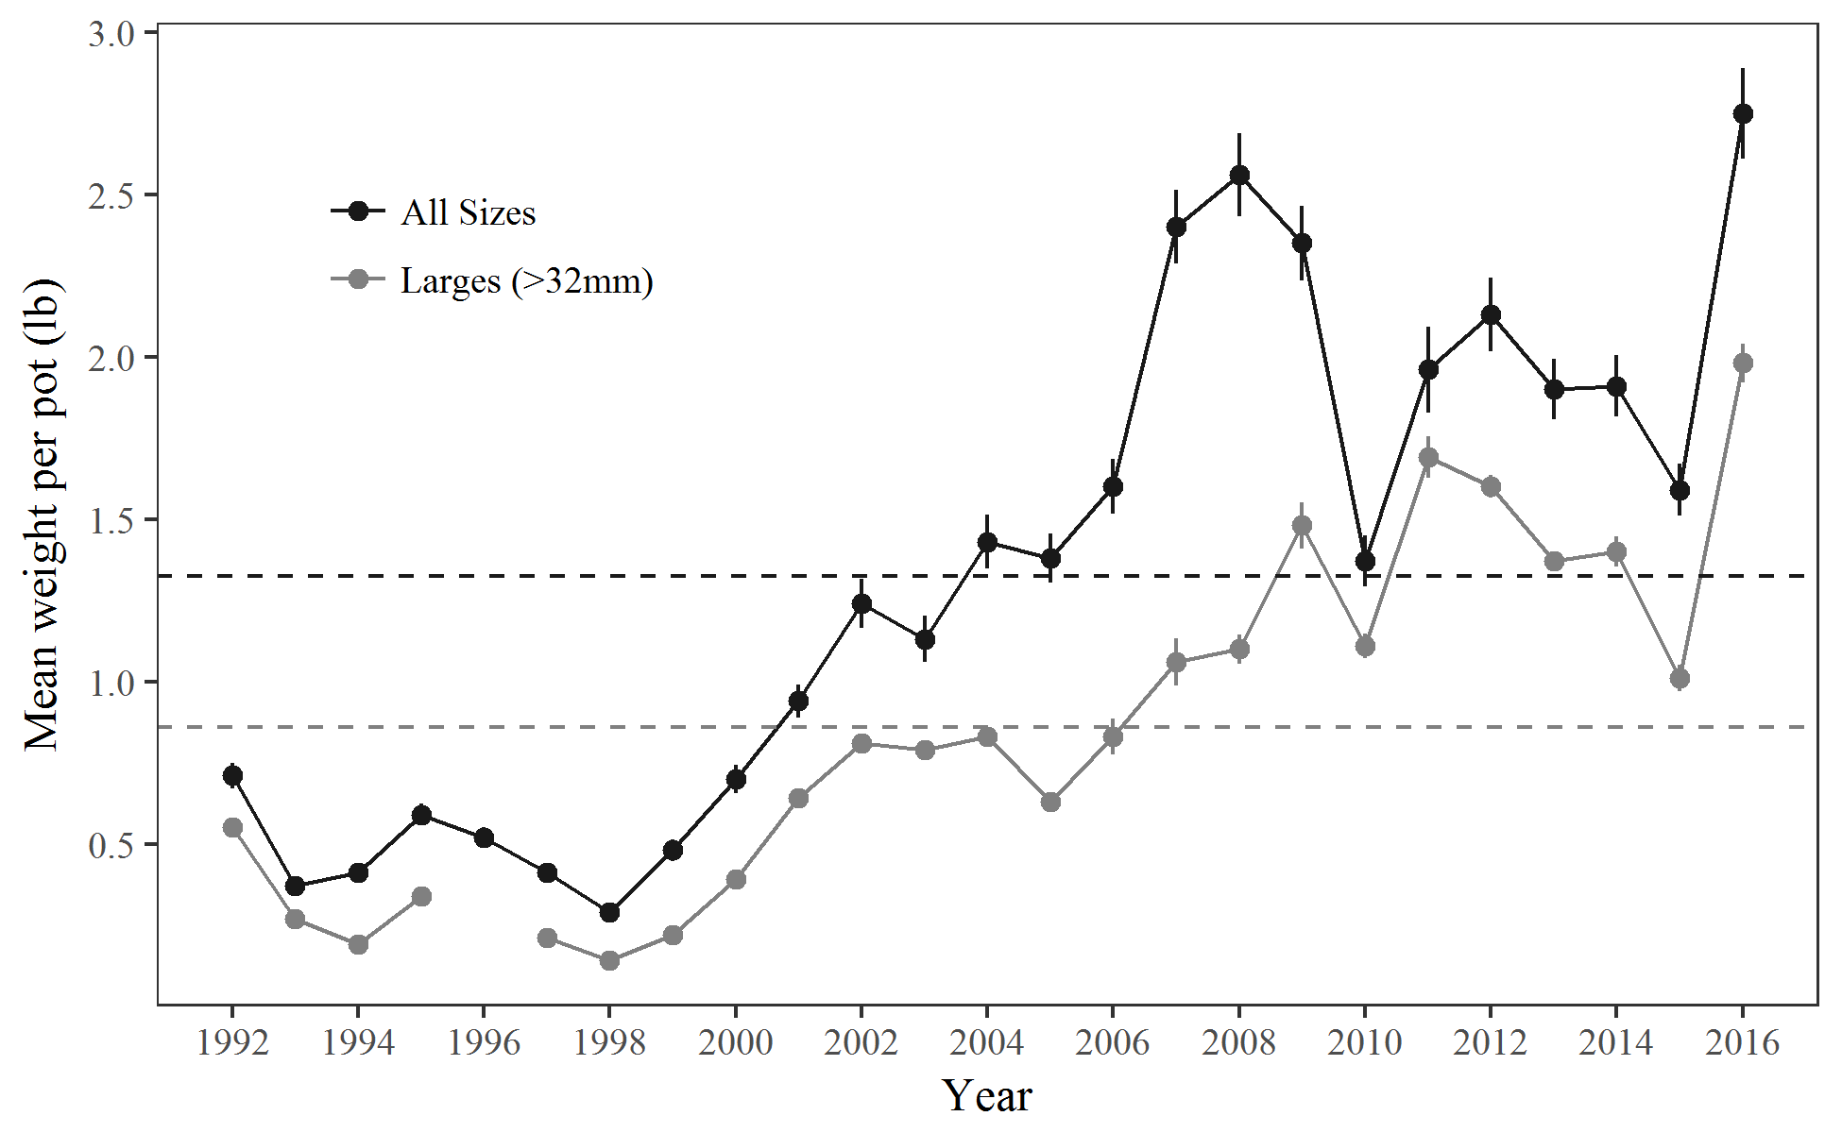

Figure 3.–Survey-wide CPUE of spot shrimp in the PWS pot survey. Baselines are 1992–2016 averages and error bars are ±1 SE.

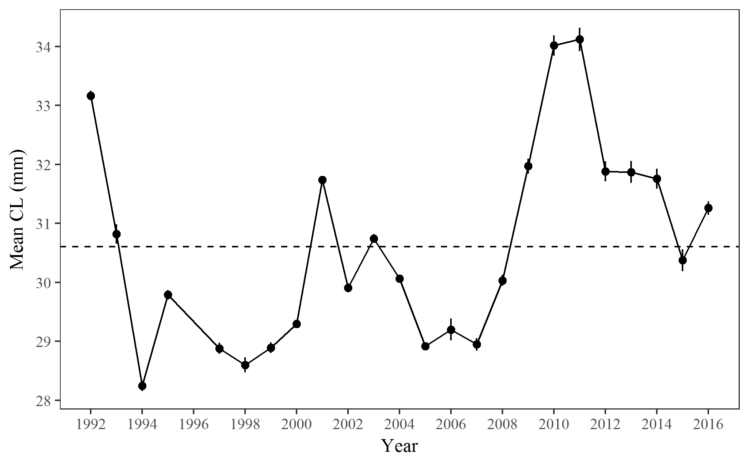

Figure 4.–Survey-wide mean carapace length ±1 SE of spot shrimp in the PWS pot survey with 1992-2016 average.

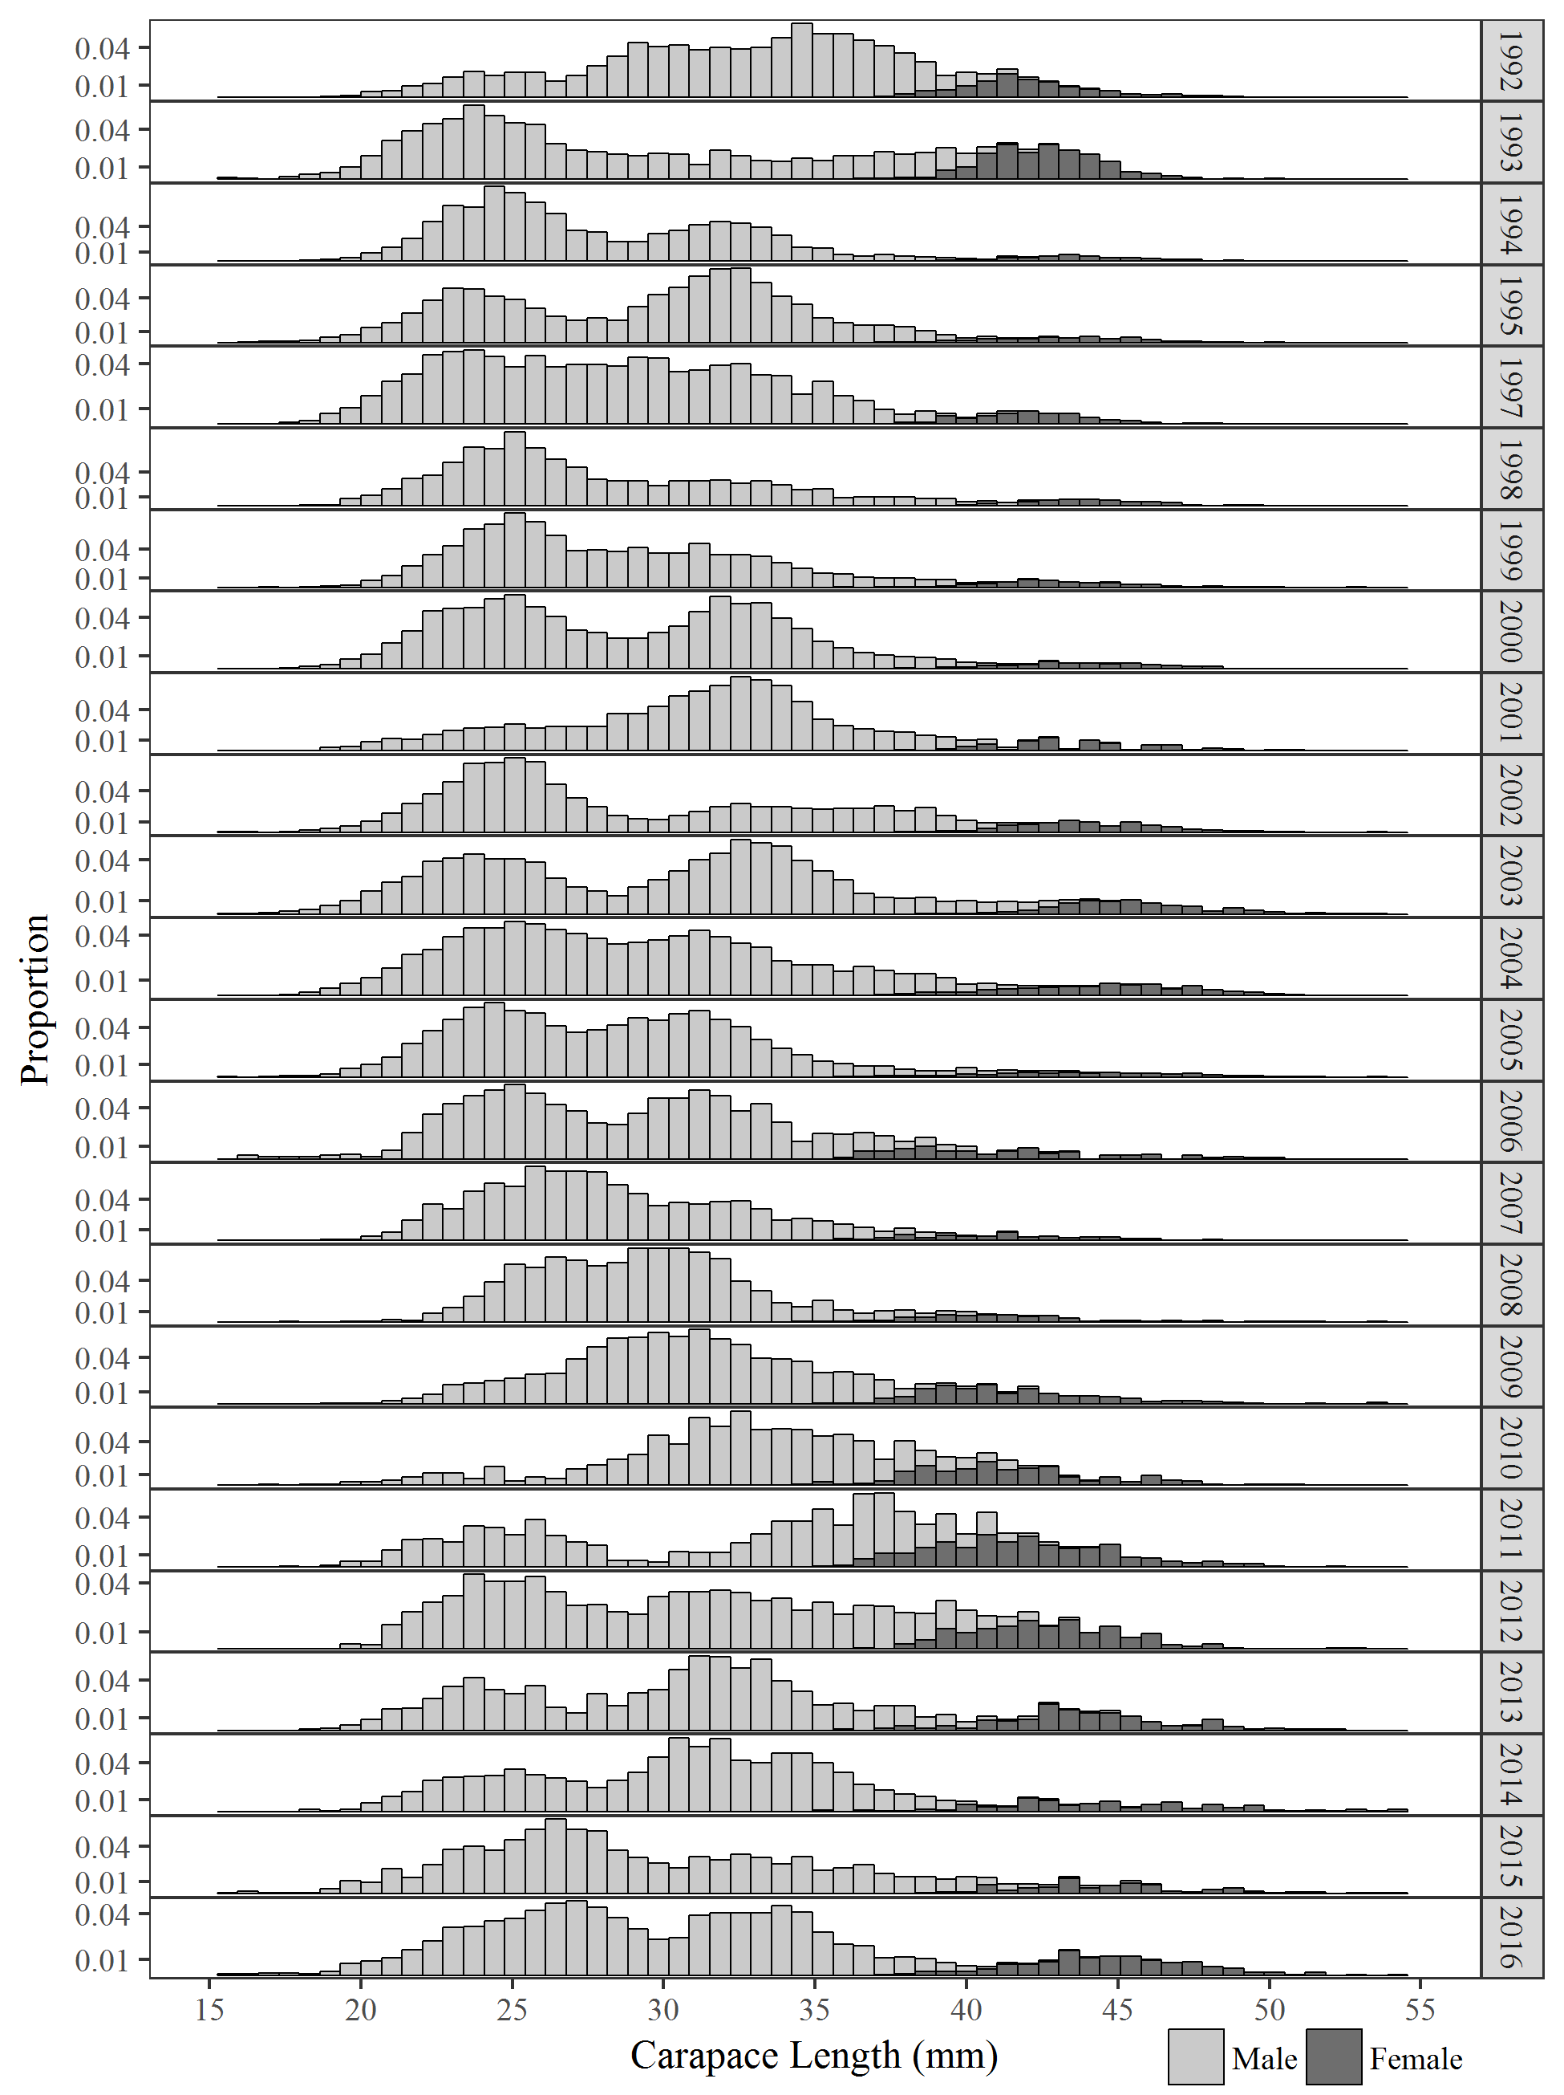

Figure 5.–Length frequencies of spot shrimp in the PWS spot pot survey, 1992–2016.

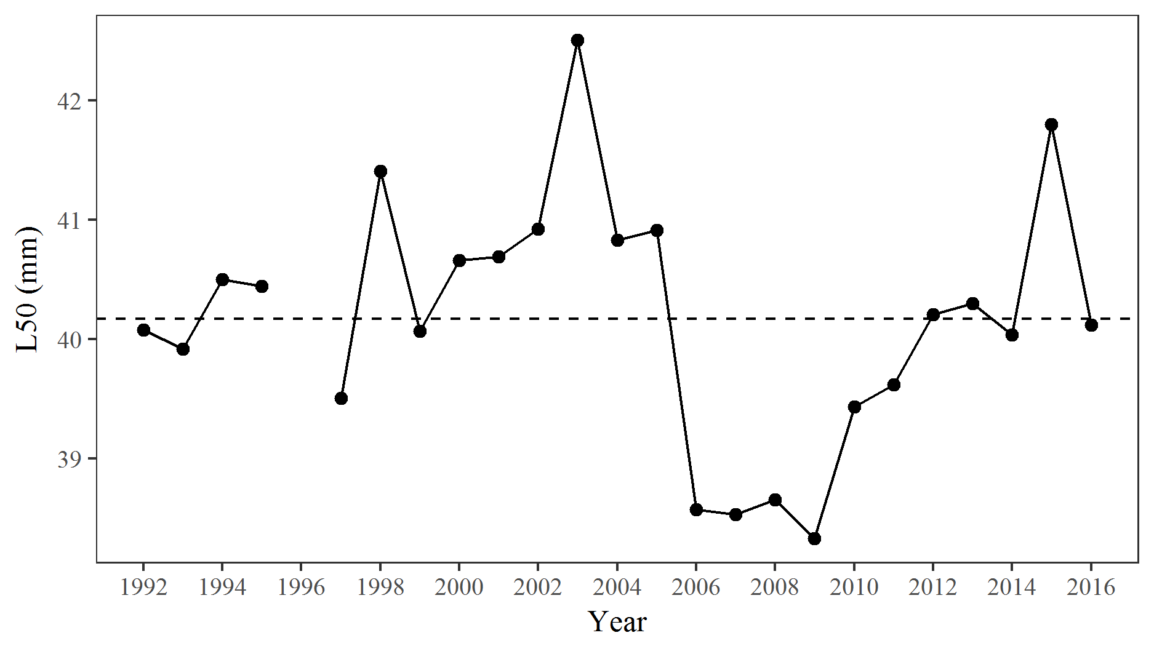

Figure 6.–Length at 50% female (L50) of spot shrimp in the PWS pot survey with 1992­–2016 average.

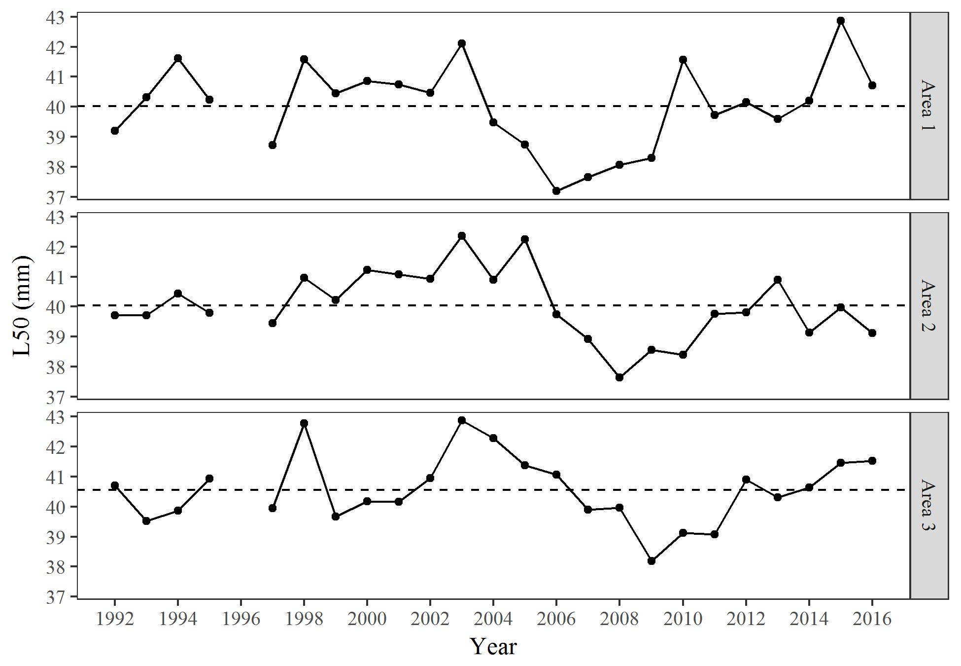

Figure 7.–Length at 50% female (L50) by harvest area of spot shrimp in the PWS pot survey with 1992­–2016 averages.

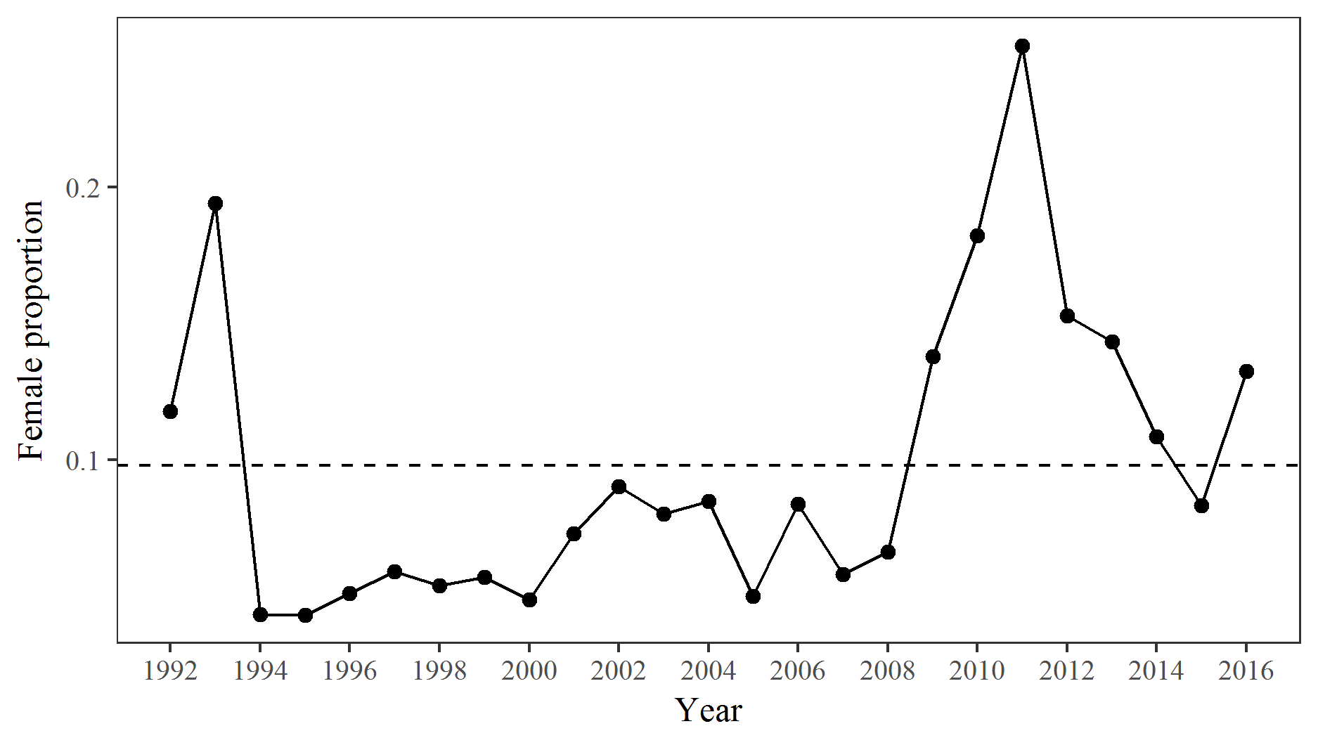

Figure 8.–Proportion of females in the spot shrimp catch of the PWS pot survey with 1992­–2016 average.

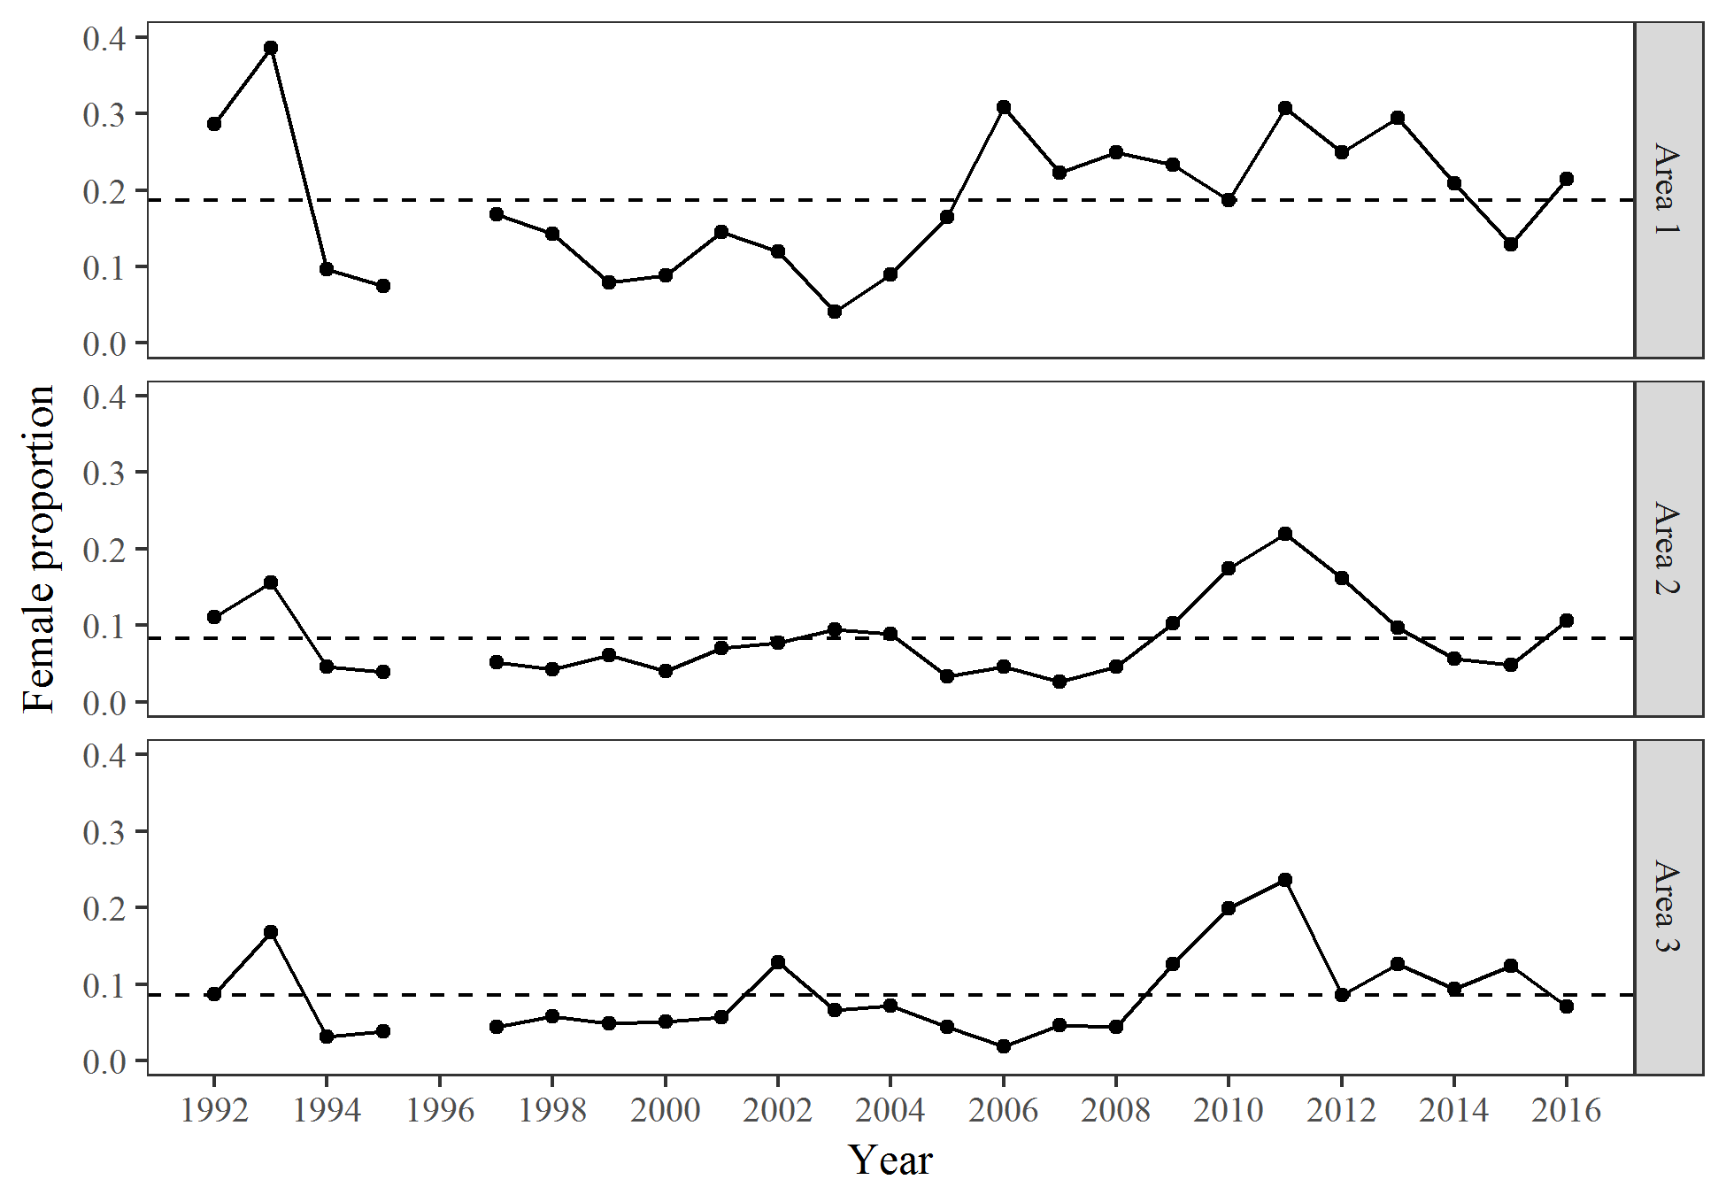

Figure 9.–Proportion of females in the spot shrimp catch of the PWS pot survey by harvest area with 1992­–2016 averages.

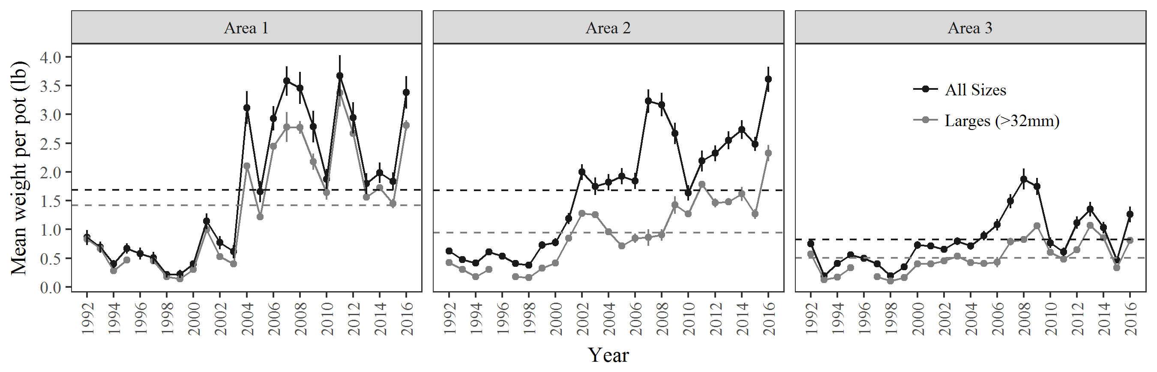

Figure 10.–CPUE of spot shrimp by harvest area in the PWS pot survey. Baselines are 1992­–2016 averages and error bars are ±1 SE.

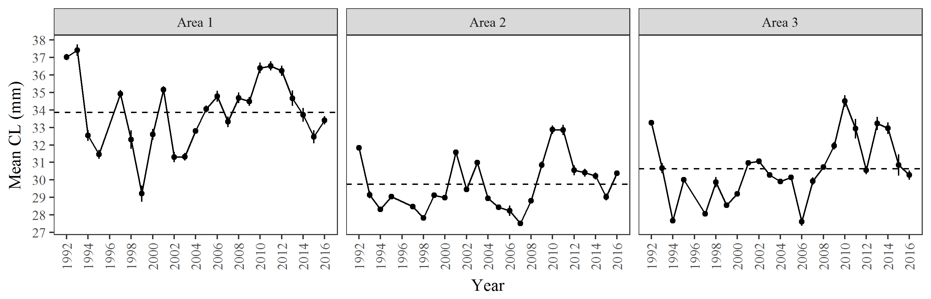

Figure 11.–Mean carapace length of spot shrimp ±1 SE by harvest area in the PWS pot survey. Baselines are 1992–2016 averages.

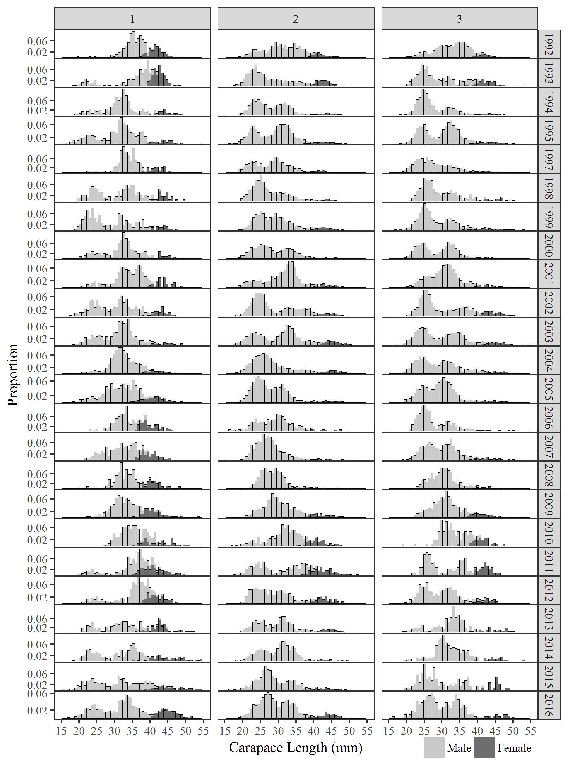

Figure 12.–Length frequencies of spot shrimp by harvest area in the PWS pot survey.

# APPENDIX A: Stations

Appendix A1.–Location and depth of stations used in the PWS pot survey.

| Site ID | Site name | Station | Latitude | Longitude | Min depth (m) | Max depth (m) |
| --- | --- | --- | --- | --- | --- | --- |
| 1 | Unakwik | A | 60.995988 | -147.543121 | 82.0 | 127.5 |
| 1 | Unakwik | B | 60.992602 | -147.547878 | 46.0 | 111.8 |
| 1 | Unakwik | C | 60.913596 | -147.550973 | 54.1 | 120.7 |
| 1 | Unakwik | D | 60.909139 | -147.552009 | 56.7 | 169.6 |
| 1 | Unakwik | W | 60.979800 | -147.608533 | 67.7 | 137.2 |
| 1 | Unakwik | X | 60.896250 | -147.532033 | 53.0 | 151.8 |
| 1 | Unakwik | Y | 60.878760 | -147.560016 | 84.1 | 94.4 |
| 1 | Unakwik | Z | 60.879016 | -147.545683 | 109.7 | 160.9 |
| 2 | Golden | A | 60.963007 | -148.027535 | 54.1 | 129.6 |
| 2 | Golden | B | 60.961113 | -148.030769 | 61.4 | 134.5 |
| 2 | Golden | C | 60.958980 | -148.034300 | 56.4 | 133.2 |
| 2 | Golden | D | 60.956817 | -148.037829 | 71.8 | 162.0 |
| 2 | Golden | W | 60.995500 | -148.087600 | 67.7 | 142.6 |
| 2 | Golden | X | 60.999716 | -148.071683 | 67.7 | 146.3 |
| 2 | Golden | Y | 60.991630 | -148.063933 | 75.0 | 142.6 |
| 2 | Golden | Z | 60.955283 | -148.040283 | 62.2 | 111.6 |
| 3 | Culross | A | 60.600683 | -148.197250 | 59.3 | 163.0 |
| 3 | Culross | B | 60.600760 | -148.191983 | 76.3 | 156.0 |
| 3 | Culross | C | 60.601360 | -148.188516 | 53.8 | 127.0 |
| 3 | Culross | D | 60.602783 | -148.184916 | 72.9 | 140.6 |
| 3 | Culross | W | 60.617550 | -148.145116 | 75.0 | 150.0 |
| 3 | Culross | X | 60.611960 | -148.154316 | 73.2 | 137.2 |
| 3 | Culross | Y | 60.609860 | -148.159233 | 73.2 | 182.9 |
| 3 | Culross | Z | 60.607883 | -148.174733 | 73.2 | 118.9 |
| 4 | Herring Bay | A | 60.479816 | -147.767183 | 60.9 | 151.8 |
| 4 | Herring Bay | B | 60.477854 | -147.766588 | 77.6 | 164.3 |
| 4 | Herring Bay | C | 60.476727 | -147.766149 | 75.0 | 127.0 |
| 4 | Herring Bay | D | 60.472250 | -147.766959 | 92.7 | 129.1 |
| 4 | Herring Bay | W | 60.481700 | -147.734733 | 67.7 | 192.0 |
| 4 | Herring Bay | X | 60.476283 | -147.735483 | 67.7 | 124.4 |
| 4 | Herring Bay | Y | 60.465400 | -147.749800 | 71.3 | 109.7 |
| 4 | Herring Bay | Z | 60.466816 | -147.765050 | 69.5 | 133.5 |
| 5 | Junction Island | A | 60.410991 | -147.970801 | 53.3 | 122.0 |
| 5 | Junction Island | B | 60.410450 | -147.967416 | 60.4 | 103.5 |
| 5 | Junction Island | C | 60.382630 | -147.988683 | 52.8 | 106.9 |
| 5 | Junction Island | D | 60.381016 | -147.988950 | 48.6 | 94.3 |
| 5 | Junction Island | W | 60.395730 | -148.004833 | 71.3 | 128.0 |
| 5 | Junction Island | X | 60.406000 | -147.993450 | 71.3 | 129.8 |
| 5 | Junction Island | Y | 60.401183 | -147.979333 | 78.6 | 164.6 |
| 5 | Junction Island | Z | 60.392050 | -147.985416 | 69.5 | 118.9 |
| 6 | Green Is/Montague | A | 60.275198 | -147.541715 | 78.7 | 99.4 |
| 6 | Green Is/Montague | B | 60.274612 | -147.545563 | 71.7 | 124.5 |
| 6 | Green Is/Montague | C | 60.273787 | -147.548602 | 59.0 | 116.9 |
| 6 | Green Is/Montague | D | 60.271698 | -147.552327 | 70.1 | 116.9 |
| 7 | Chenega | A | 60.291297 | -148.149445 | 71.8 | 174.0 |
| 7 | Chenega | B | 60.289557 | -148.145753 | 68.2 | 161.5 |
| 7 | Chenega | C | 60.277324 | -148.130391 | 60.1 | 140.8 |
| 7 | Chenega | D | 60.275277 | -148.124667 | 52.0 | 129.1 |
| 7 | Chenega | W | 60.279000 | -148.194866 | 76.8 | 151.8 |
| 7 | Chenega | X | 60.274183 | -148.188216 | 71.3 | 164.6 |
| 7 | Chenega | Y | 60.265830 | -148.185016 | 78.6 | 179.2 |
| 7 | Chenega | Z | 60.262750 | -148.194833 | 62.2 | 128.0 |
| 8 | Prince of Wales | A | 60.184017 | -148.029788 | 65.3 | 137.2 |
| 8 | Prince of Wales | B | 60.183417 | -148.003857 | 58.3 | 181.3 |
| 8 | Prince of Wales | C | 60.139142 | -147.989381 | 53.0 | 101.4 |
| 8 | Prince of Wales | D | 60.131849 | -148.002365 | 58.8 | 145.0 |
| 8 | Prince of Wales | W | 60.178560 | -148.042683 | 69.5 | 140.8 |
| 8 | Prince of Wales | X | 60.201460 | -148.038083 | 65.8 | 170.1 |
| 8 | Prince of Wales | Y | 60.190950 | -148.012683 | 73.2 | 201.2 |
| 8 | Prince of Wales | Z | 60.175516 | -147.995766 | 56.7 | 137.2 |
| 9 | Long Bay | A | 60.962016 | -147.245499 | 67.9 | 132.2 |
| 9 | Long Bay | B | 60.958499 | -147.246833 | 88.8 | 144.2 |
| 9 | Long Bay | C | 60.965666 | -147.230466 | 65.8 | 135.3 |
| 9 | Long Bay | D | 60.962283 | -147.231083 | 66.6 | 146.8 |
| 9 | Long Bay | W | 60.972900 | -147.242183 | 82.3 | 142.6 |
| 9 | Long Bay | X | 60.945100 | -147.234616 | 84.1 | 113.9 |
| 9 | Long Bay | Y | 60.930400 | -147.227550 | 82.3 | 160.9 |
| 9 | Long Bay | Z | 60.931816 | -147.243616 | 76.8 | 100.6 |
| 10 | Bald Head Chris | A | 60.793566 | -147.863333 | 69.1 | 127.3 |
| 10 | Bald Head Chris | B | 60.788449 | -147.836266 | 51.2 | 118.9 |
| 10 | Bald Head Chris | C | 60.788216 | -147.866116 | 122.2 | 148.9 |
| 10 | Bald Head Chris | D | 60.785716 | -147.859999 | 60.4 | 113.8 |
| 10 | Bald Head Chris | W | 60.791060 | -147.817800 | 75.0 | 139.0 |
| 10 | Bald Head Chris | X | 60.783030 | -147.800383 | 73.2 | 115.2 |
| 10 | Bald Head Chris | Y | 60.780300 | -147.842933 | 78.6 | 151.8 |
| 10 | Bald Head Chris | Z | 60.806460 | -147.859233 | 69.5 | 148.1 |
| 11 | Valdez | A | 61.046433 | -146.646600 | 73.8 | 149.4 |
| 11 | Valdez | B | 61.044699 | -146.642499 | 52.4 | 184.1 |
| 11 | Valdez | C | 61.085349 | -146.670766 | 57.9 | 152.4 |
| 11 | Valdez | D | 61.087983 | -146.669316 | 64.0 | 183.5 |

# APPENDIX B: CPUE by StatisTIcal Area

Appendix B1.–CPUE (lb/pot) of spot shrimp in the PWS spot survey and commercial fishery by statistical area.

|  |  |  |  |  |  |  |  |  |  |  |  |  |  |  |  |  |  |  |  |  |  |  |  |  |  |  |  |  |
| --- | --- | --- | --- | --- | --- | --- | --- | --- | --- | --- | --- | --- | --- | --- | --- | --- | --- | --- | --- | --- | --- | --- | --- | --- | --- | --- | --- | --- |
|  | 466100 |  | 476006 | |  | 476007 | |  | 476033 | |  | 476035 | |  | 476036 | |  | 486001 | |  | 486005 | |  | 486031 | |  | 486034 | |
| Year | Survey |  | Survey | Fishery |  | Survey | Fishery |  | Survey | Fishery |  | Survey | Fishery |  | Survey | Fishery |  | Survey | Fishery |  | Survey | Fishery |  | Survey | Fishery |  | Survey | Fishery |
| 1992 | nd |  | 0.84 | nd |  | 0.63 | nd |  | nd | nd |  | nd | nd |  | 0.86 | nd |  | 0.53 | nd |  | 0.87 | nd |  | 0.56 | nd |  | 0.57 | nd |
| 1993 | nd |  | 0.27 | nd |  | 0.12 | nd |  | nd | nd |  | nd | nd |  | 0.69 | nd |  | 0.21 | nd |  | 0.21 | nd |  | 0.47 | nd |  | 0.63 | nd |
| 1994 | nd |  | 0.36 | nd |  | 0.18 | nd |  | nd | nd |  | nd | nd |  | 0.40 | nd |  | 0.70 | nd |  | 0.48 | nd |  | 0.24 | nd |  | 0.53 | nd |
| 1995 | nd |  | 0.44 | nd |  | 0.26 | nd |  | nd | nd |  | nd | nd |  | 0.67 | nd |  | 1.01 | nd |  | 0.69 | nd |  | 0.76 | nd |  | 0.44 | nd |
| 1996 | nd |  | 0.47 | nd |  | 0.68 | nd |  | nd | nd |  | nd | nd |  | 0.58 | nd |  | 0.73 | nd |  | 0.23 | nd |  | 0.66 | nd |  | 0.34 | nd |
| 1997 | nd |  | 0.47 | nd |  | 0.48 | nd |  | nd | nd |  | nd | nd |  | 0.50 | nd |  | 0.55 | nd |  | 0.21 | nd |  | 0.39 | nd |  | 0.24 | nd |
| 1998 | nd |  | 0.38 | nd |  | nd | nd |  | nd | nd |  | nd | nd |  | 0.22 | nd |  | nd | nd |  | 0.26 | nd |  | 0.37 | nd |  | 0.14 | nd |
| 1999 | nd |  | 0.48 | nd |  | 0.27 | nd |  | nd | nd |  | nd | nd |  | 0.22 | nd |  | 0.22 | nd |  | 0.62 | nd |  | 0.90 | nd |  | 0.58 | nd |
| 2000 | nd |  | 0.53 | nd |  | 0.65 | nd |  | nd | nd |  | nd | nd |  | 0.40 | nd |  | 0.54 | nd |  | 1.29 | nd |  | 0.78 | nd |  | 0.92 | nd |
| 2001 | nd |  | 0.53 | nd |  | 0.93 | nd |  | nd | nd |  | nd | nd |  | 1.14 | nd |  | 0.69 | nd |  | 0.75 | nd |  | 1.00 | nd |  | 1.96 | nd |
| 2002 | nd |  | 1.05 | nd |  | nd | nd |  | nd | nd |  | nd | nd |  | 0.77 | nd |  | 0.46 | nd |  | 0.91 | nd |  | 1.47 | nd |  | 2.94 | nd |
| 2003 | nd |  | 0.70 | nd |  | 1.01 | nd |  | nd | nd |  | nd | nd |  | 0.61 | nd |  | 0.51 | nd |  | 1.31 | nd |  | 1.23 | nd |  | 2.97 | nd |
| 2004 | nd |  | 0.96 | nd |  | 0.60 | nd |  | nd | nd |  | nd | nd |  | 3.12 | nd |  | 0.48 | nd |  | 1.45 | nd |  | 0.57 | nd |  | 3.27 | nd |
| 2005 | nd |  | 0.88 | nd |  | 0.78 | nd |  | nd | nd |  | nd | nd |  | 1.66 | nd |  | 0.33 | nd |  | 1.91 | nd |  | 1.06 | nd |  | 3.47 | nd |
| 2006 | nd |  | 0.82 | nd |  | 0.44 | nd |  | nd | nd |  | nd | nd |  | 2.93 | nd |  | 0.82 | nd |  | 2.21 | nd |  | 1.30 | nd |  | 3.40 | nd |
| 2007 | nd |  | 1.68 | nd |  | 0.45 | nd |  | nd | nd |  | nd | nd |  | 3.58 | nd |  | 1.46 | nd |  | 2.67 | nd |  | 1.83 | nd |  | 5.92 | nd |
| 2008 | nd |  | 1.83 | nd |  | 0.46 | nd |  | nd | nd |  | nd | nd |  | 3.46 | nd |  | 1.70 | nd |  | 4.15 | nd |  | 1.66 | nd |  | 5.28 | nd |
| 2009 | nd |  | 1.18 | nd |  | nd | nd |  | nd | nd |  | 0.62 | nd |  | 4.90 | nd |  | 1.26 | nd |  | 3.17 | nd |  | 1.74 | nd |  | 4.70 | nd |
| 2010 | nd |  | 0.53 | nd |  | nd | nd |  | nd | 2.04 |  | 0.87 | 4.20 |  | 2.88 | 2.65 |  | 0.41 | nd |  | 1.66 | nd |  | 1.20 | nd |  | 2.84 | nd |
| 2011 | nd |  | 0.55 | 0.52 |  | nd | nd |  | nd | nd |  | 1.07 | nd |  | 6.34 | nd |  | 0.26 | nd |  | 1.48 | nd |  | 1.24 | 1.36 |  | 4.27 | 1.87 |
| 2012 | nd |  | 1.47 | nd |  | nd | 0.17 |  | 1.54 | nd |  | 0.54 | nd |  | 6.74 | nd |  | 0.89 | 1.00 |  | 1.47 | 1.06 |  | 1.77 | nd |  | 3.19 | nd |
| 2013 | 2.43 |  | 1.13 | nd |  | nd | nd |  | 0.79 | 1.19 |  | 0.33 | 1.48 |  | 4.29 | 2.37 |  | 1.44 | nd |  | 1.79 | nd |  | 1.94 | nd |  | 4.31 | nd |
| 2014 | 2.07 |  | 1.04 | nd |  | nd | nd |  | 1.33 | nd |  | 0.43 | nd |  | 4.16 | nd |  | 0.72 | nd |  | 1.89 | nd |  | 2.47 | 1.62 |  | 4.14 | 1.49 |
| 2015 | 2.33 |  | 1.44 | nd |  | nd | nd |  | 2.13 | nd |  | 0.55 | nd |  | 2.83 | nd |  | 0.37 | 1.24 |  | 0.63 | 1.16 |  | 1.80 | nd |  | 3.14 | nd |
| 2016 | nd |  | 1.56 | nd |  | nd | nd |  | 3.24 | 1.42 |  | 0.88 | 1.48 |  | 6.01 | 2.85 |  | 1.11 | nd |  | 1.46 | nd |  | 3.73 | nd |  | 5.19 | nd |

*Note:* All sizes of shrimp are included.

*Note:* Only statistical areas containing survey sites are included.

# APPENDIX C: Ovigerity by statistical Area

Appendix C1.–Percent of female spot shrimp with eggs in the PWS spot survey by statistical area.

|  |  |  |  |  |  |  |  |  |  |  |  |
| --- | --- | --- | --- | --- | --- | --- | --- | --- | --- | --- | --- |
| Year | 466100 | 476006 | 476007 | 476033 | 476035 | 476036 | 486001 | 486005 | 486031 | 486034 | Survey-wide |
| 1992 | nd | 97.1 | 96.3 | nd | nd | 93.4 | 100.0 | 99.0 | 100.0 | 97.5 | 96.8 |
| 1993 | nd | 100.0 | 87.5 | nd | nd | 96.6 | 100.0 | 91.4 | 97.0 | 100.0 | 97.7 |
| 1994 | nd | 85.2 | 85.7 | nd | nd | 100.0 | 93.2 | 100.0 | 100.0 | 100.0 | 95.5 |
| 1995 | nd | – | – | nd | nd | – | – | – | – | – | – |
| 1996 | nd | – | – | nd | nd | – | – | – | – | – | – |
| 1997 | nd | – | – | nd | nd | – | – | – | – | – | – |
| 1998 | nd | 100.0 | nd | nd | nd | 100.0 | nd | 100.0 | 100.0 | 95.7 | 99.2 |
| 1999 | nd | 97.1 | 100.0 | nd | nd | 100.0 | 100.0 | 100.0 | 97.1 | 94.4 | 97.8 |
| 2000 | nd | 94.6 | 93.5 | nd | nd | 100.0 | 100.0 | 97.0 | 100.0 | 97.5 | 97.2 |
| 2001 | nd | 100.0 | 100.0 | nd | nd | 98.1 | 100.0 | 100.0 | 100.0 | 100.0 | 99.6 |
| 2002 | nd | 96.6 | nd | nd | nd | 95.2 | 98.2 | 100.0 | 97.7 | 100.0 | 98.5 |
| 2003 | nd | 98.6 | 100.0 | nd | nd | 100.0 | 100.0 | 99.2 | 100.0 | 100.0 | 99.7 |
| 2004 | nd | 96.8 | 93.9 | nd | nd | 98.0 | 100.0 | 96.6 | 90.0 | 98.2 | 97.3 |
| 2005 | nd | 96.9 | 91.3 | nd | nd | 92.9 | 100.0 | 95.9 | 94.4 | 98.4 | 95.0 |
| 2006 | nd | 100.0 | 100.0 | nd | nd | 90.9 | 100.0 | 100.0 | 50.0 | 100.0 | 91.7 |
| 2007 | nd | 80.0 | 100.0 | nd | nd | 77.3 | 50.0 | 100.0 | 100.0 | 94.4 | 83.7 |
| 2008 | nd | 77.8 | nd | nd | nd | 78.7 | 100.0 | 87.1 | 100.0 | 80.4 | 81.4 |
| 2009 | nd | 93.1 | nd | nd | 75.0 | 89.3 | 66.7 | 82.1 | 93.3 | 88.9 | 88.0 |
| 2010 | nd | 94.6 | nd | nd | 100.0 | 83.3 | 88.9 | 95.7 | 92.1 | 100.0 | 93.5 |
| 2011 | nd | 100.0 | nd | nd | 100.0 | 98.4 | 100.0 | 100.0 | 95.0 | 100.0 | 99.1 |
| 2012 | nd | 87.5 | nd | 100.0 | 100.0 | 84.5 | 96.2 | 90.5 | 87.5 | 96.1 | 90.8 |
| 2013 | 94.4 | 100.0 | nd | 100.0 | 50.0 | 69.7 | 100.0 | 95.5 | 100.0 | 100.0 | 87.1 |
| 2014 | 88.9 | 100.0 | nd | 77.8 | 88.9 | 98.4 | 33.3 | 80.0 | 100.0 | 100.0 | 93.1 |
| 2015 | 100.0 | 100.0 | nd | 100.0 | 100.0 | 96.8 | 100.0 | 100.0 | 92.9 | 100.0 | 98.3 |
| 2016 | nd | 100.0 | nd | 100.0 | 100.0 | 100.0 | 100.0 | 100.0 | 99.0 | 98.7 | 99.6 |

*Note:* Ovigerity data from 1995–1997 are missing.

*Note:* The survey-wide values do not include the Valdez site which is outside the commercial harvest area.